**VISVESVARAYA TECHNOLOGICAL UNIVERSITY**

**“JnanaSangama”, Belgaum -590014, Karnataka.**



**LAB REPORT**

**on**

**Artificial Intelligence (23CS5PCAIN)**

***Submitted by***

**Sthavir Kiran Kulkarni (1BM23CS342)**

***in partial fulfillment for the award of the degree of***

**BACHELOR OF ENGINEERING**

***in***

**COMPUTER SCIENCE AND ENGINEERING**



**B.M.S. COLLEGE OF ENGINEERING**

**(Autonomous Institution under VTU)**

**BENGALURU-560019**

**Aug 2025 to Dec 2025**

**B.M.S. College of Engineering,**

**Bull Temple Road, Bangalore 560019**

(Affiliated To Visvesvaraya Technological University, Belgaum)

**Department of Computer Science and Engineering**



**CERTIFICATE**

This is to certify that the Lab work entitled “Artificial Intelligence (23CS5PCAIN)” carried out by **Sthavir Kiran Kulkarni(1BM23CS342),** who is Bonafide student of **B.M.S. College of Engineering.** It is in partial fulfillment for the award of **Bachelor of Engineering in Computer Science and Engineering** of the Visvesvaraya Technological University, Belgaum. The Lab report has been approved as it satisfies the academic requirements in respect of an Artificial Intelligence (23CS5PCAIN) work prescribed for the said degree.

|  |  |
| --- | --- |
| Dr. Seema Patil  Assistant Professor  Department of CSE, BMSCE | Dr. Kavitha Sooda  Professor & HOD  Department of CSE, BMSCE |

**Index**

|  |  |  |  |
| --- | --- | --- | --- |
| **Sl.**  **No.** | **Date** | **Experiment Title** | **Page No.** |
| 1 | 18-08-2025 | Implement Tic –Tac –Toe Game  Implement vacuum cleaner agent |  |
| 2 | 25-08-2025 | Implement 8 puzzle problems using Depth First Search (DFS)  Implement Iterative deepening search algorithm |  |
| 3 | 01-09-2025 | Implement A* search algorithm |  |
| 4 | 08-09-2025 | Implement Hill Climbing search algorithm to solve N-Queens problem |  |
| 5 | 15-09-2025 | Simulated Annealing to Solve 8-Queens problem |  |
| 6 | 22-09-2025 | Create a knowledge base using propositional logic and show that the given query entails the knowledge base or not. |  |
| 7 | 13-10-2025 | Implement unification in first order logic |  |
| 8 | 13-10-2025 | Create a knowledge base consisting of first order logic statements and prove the given query using forward reasoning. |  |
| 9 | 27-10-2025 | Create a knowledge base consisting of first order logic statements and prove the given query using Resolution |  |
| 10 | 27-10-2025 | Implement Alpha-Beta Pruning. |  |

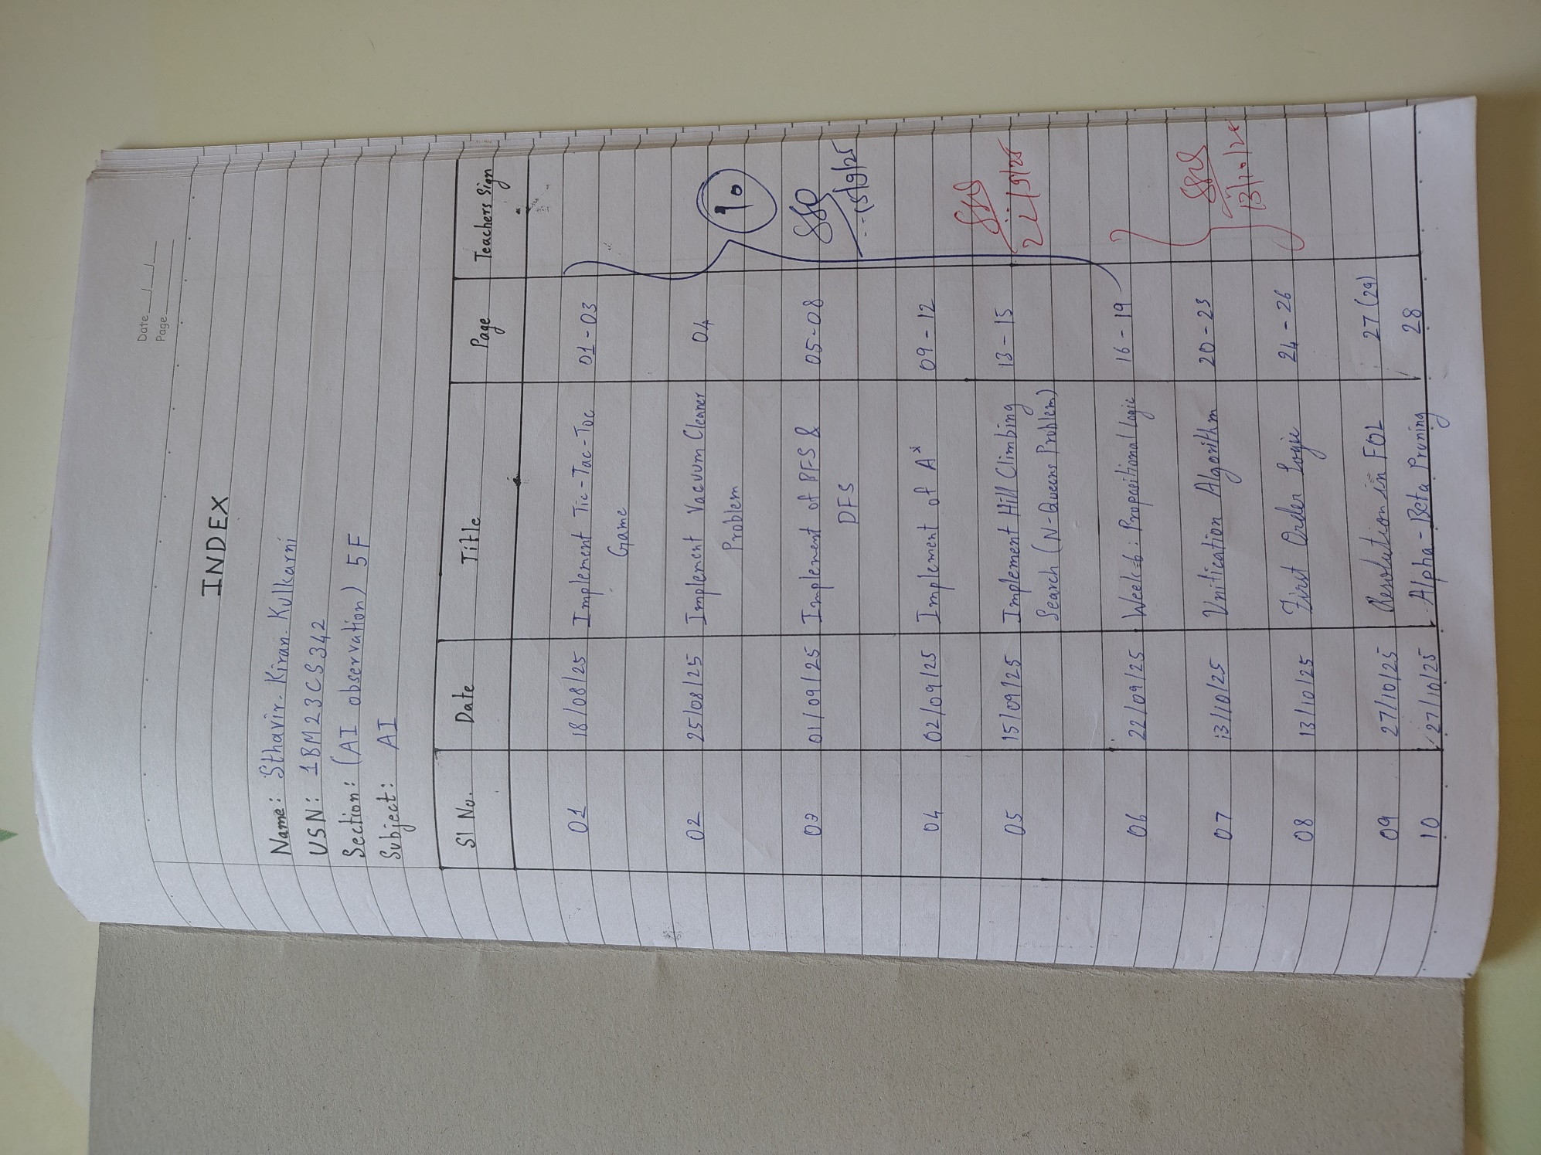Github Link : https://github.com/sthabirrr/AI-1BM23CS342

**Program 1.1**

Implement Tic –Tac –Toe Game

**Algorithm:**

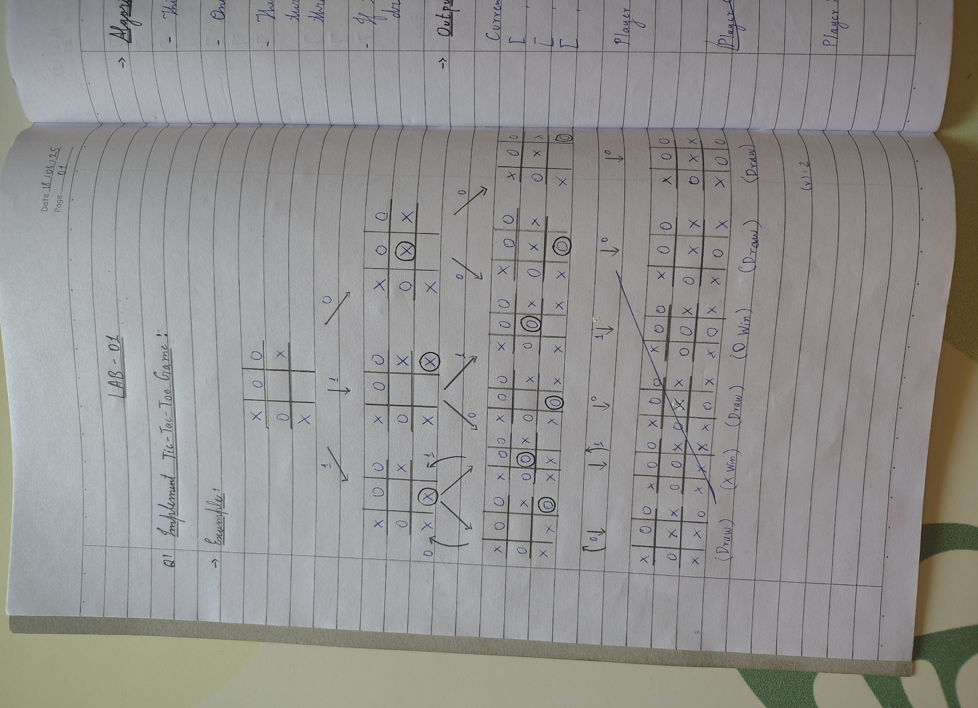

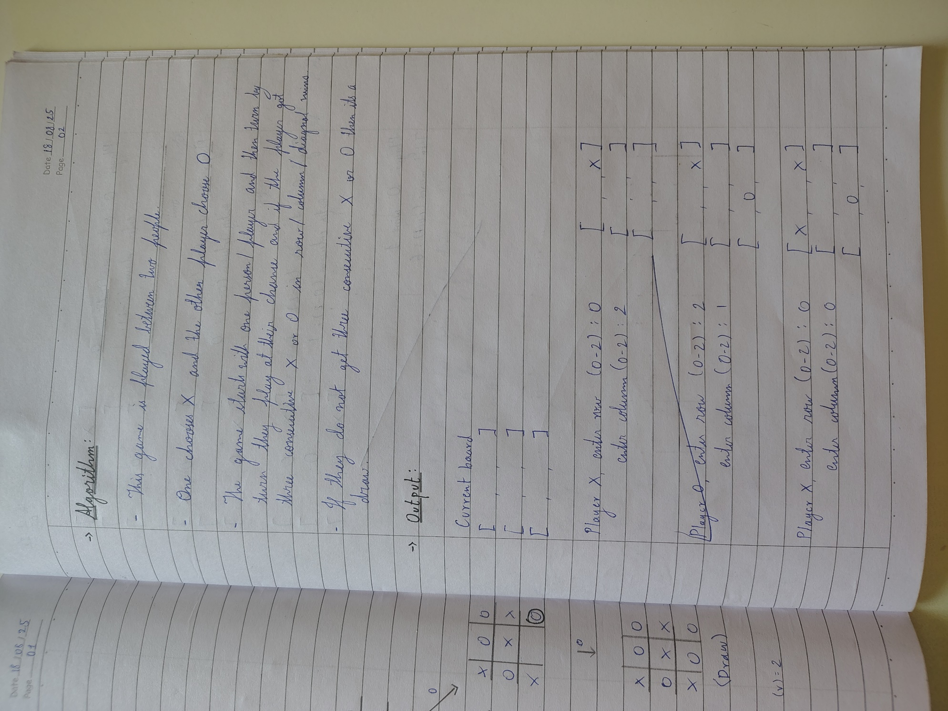 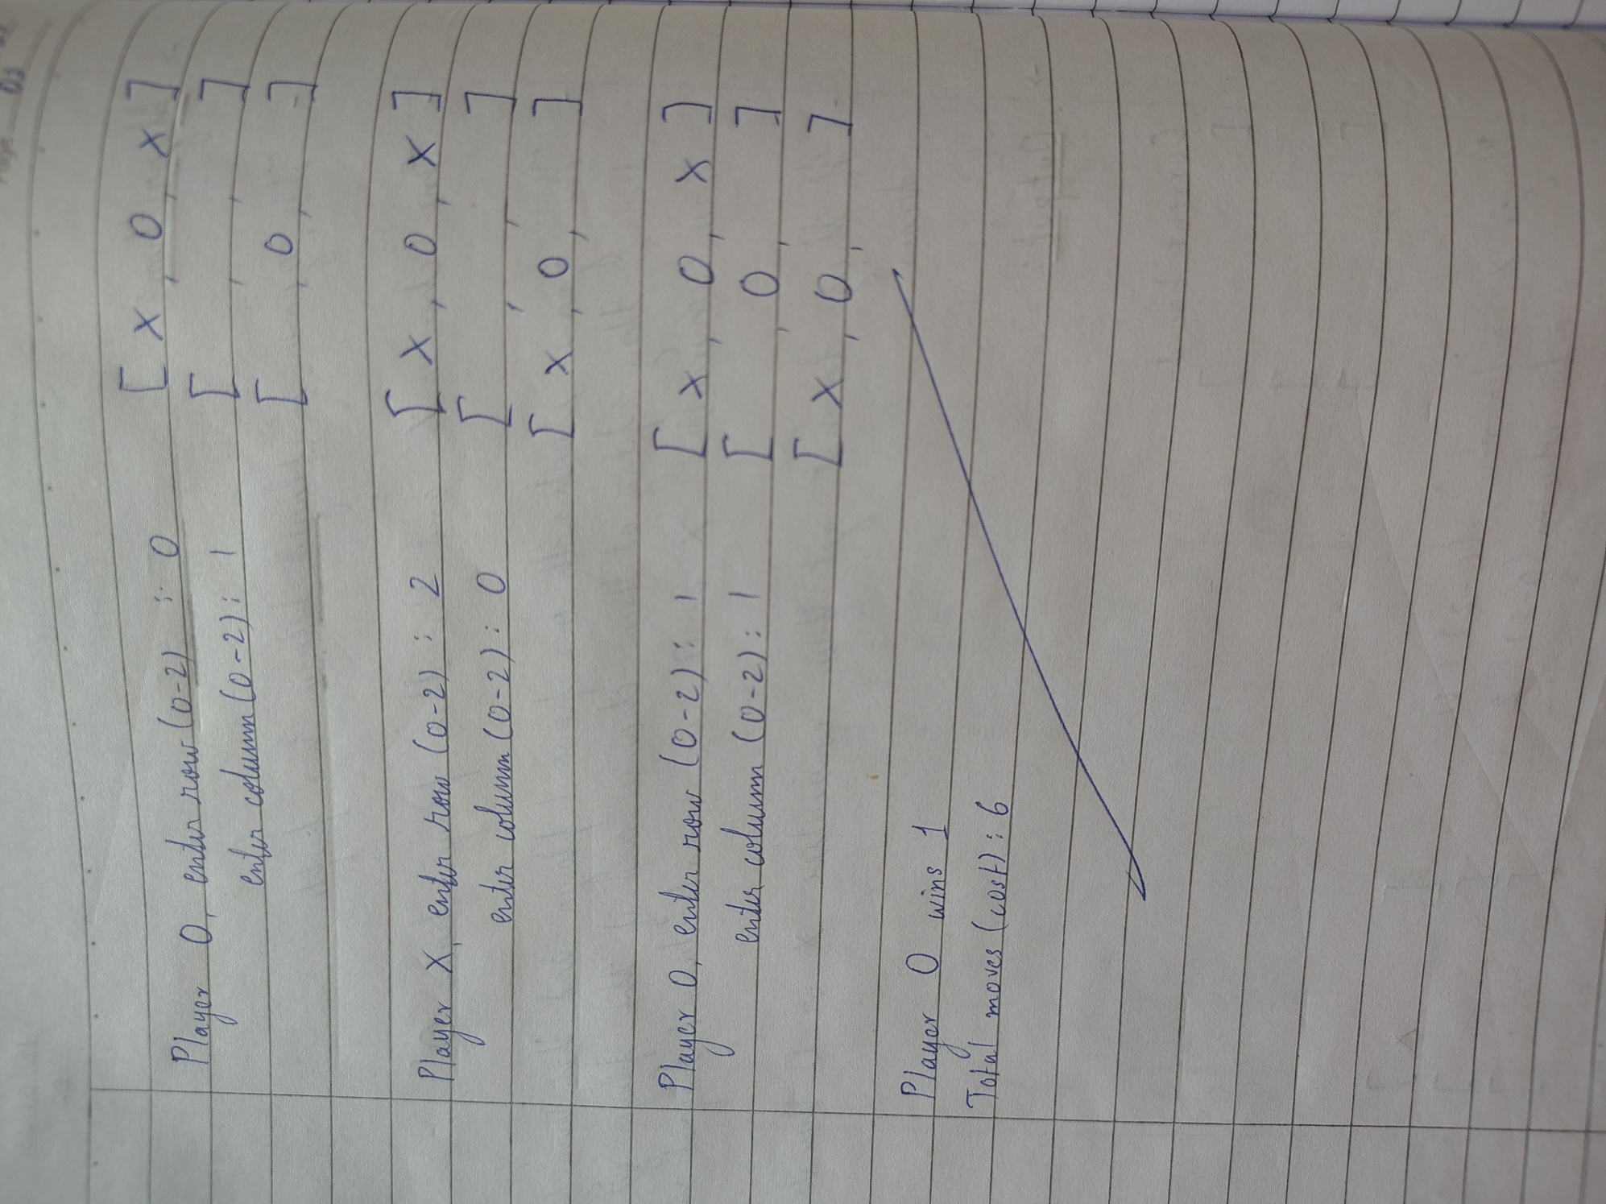

**Code:**

import math

NAME = "Sthavir K"

USN = "1BM23CS342"

*# Function to print the board*

def print_board(board):

for row in board:

print("|".join(row))

print()

*# Function to check if moves are left*

def is_moves_left(board):

for row in board:

if " " in row:

return True

return False

*# Function to evaluate board*

def evaluate(board):

*# Check rows*

for row in board:

if row.count(row[0]) == 3 and row[0] != " ":

return 10 if row[0] == "O" else -10

*# Check cols*

for col in range(3):

if board[0][col] == board[1][col] == board[2][col] != " ":

return 10 if board[0][col] == "O" else -10

*# Check diagonals*

if board[0][0] == board[1][1] == board[2][2] != " ":

return 10 if board[0][0] == "O" else -10

if board[0][2] == board[1][1] == board[2][0] != " ":

return 10 if board[0][2] == "O" else -10

return 0

*# Minimax function*

def minimax(board, depth, is_max):

score = evaluate(board)

if score == 10: return score - depth

if score == -10: return score + depth

if not is_moves_left(board): return 0

if is_max:

best = -math.inf

for i in range(3):

for j in range(3):

if board[i][j] == " ":

board[i][j] = "O"

best = max(best, minimax(board, depth + 1, False))

board[i][j] = " "

return best

else:

best = math.inf

for i in range(3):

for j in range(3):

if board[i][j] == " ":

board[i][j] = "X"

best = min(best, minimax(board, depth + 1, True))

board[i][j] = " "

return best

*# Find best move for computer*

def find_best_move(board):

best_val = -math.inf

best_move = (-1, -1)

for i in range(3):

for j in range(3):

if board[i][j] == " ":

board[i][j] = "O"

move_val = minimax(board, 0, False)

board[i][j] = " "

if move_val > best_val:

best_move = (i, j)

best_val = move_val

return best_move

*# Play game*

def play_game():

board = [[" "]*3 for _ in range(3)]

print("Tic-Tac-Toe Game! You are X, Computer is O")

print_board(board)

for turn in range(9):

if turn % 2 == 0: *# Human move*

row = int(input("Enter row (0-2): "))

col = int(input("Enter col (0-2): "))

if board[row][col] != " ":

print("Invalid move, try again.")

continue

board[row][col] = "X"

else: *# Computer move*

move = find_best_move(board)

board[move[0]][move[1]] = "O"

print(f"Computer places O at {move}")

print_board(board)

score = evaluate(board)

if score == 10:

print("Computer Wins!")

print(f"\nSubmitted by: {NAME}, USN: {USN}")

return

elif score == -10:

print("You Win!")

print(f"\nSubmitted by: {NAME}, USN: {USN}")

return

print("It's a Draw!")

print(f"\nSubmitted by: {NAME}, USN: {USN}")

play_game()

**Output:**

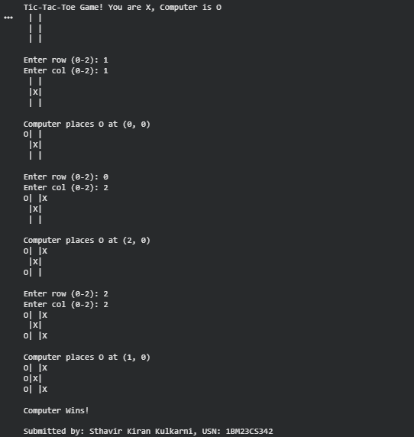

**Program 1.2**

Implement Vacuum Cleaner Agent

**Algorithm:**

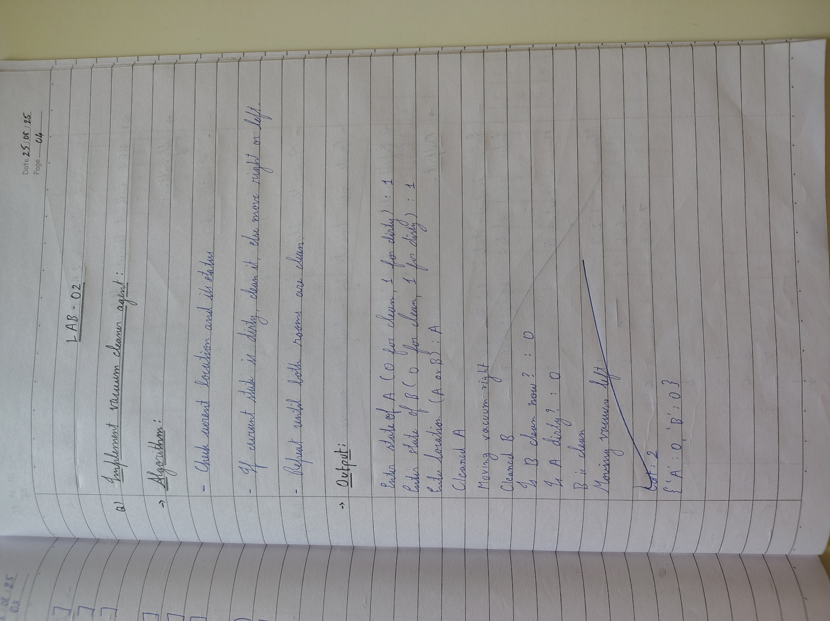

**Code:**

import random

NAME = "Sthavir K"

USN = "1BM23CS342"

def reflex_vacuum_agent(location, status):

if status == "Dirty":

return "Suck"

elif location == "A":

return "Right"

elif location == "B":

return "Left"

def vacuum_world():

locations = {"A": random.choice(["Clean", "Dirty"]),

"B": random.choice(["Clean", "Dirty"])}

location = random.choice(["A", "B"])

print("Initial State:", locations, "| Vacuum at:", location)

steps = 5

for _ in range(steps):

status = locations[location]

action = reflex_vacuum_agent(location, status)

print(f"Vacuum at {location} | Status: {status} -> Action: {action}")

if action == "Suck":

locations[location] = "Clean"

elif action == "Right":

location = "B"

elif action == "Left":

print("World State:", locations)

print("\nFinal State:", locations)

print(f"\nSubmitted by: {NAME}, USN: {USN}")

vacuum_world()

**Output:**

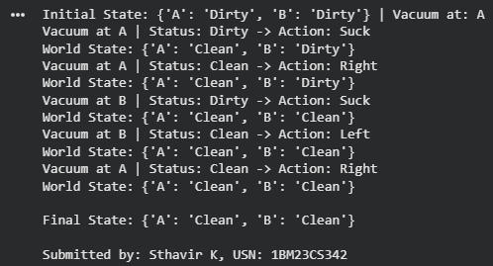

**Program 2**

Implement 8 puzzle problems using Depth First Search (DFS):

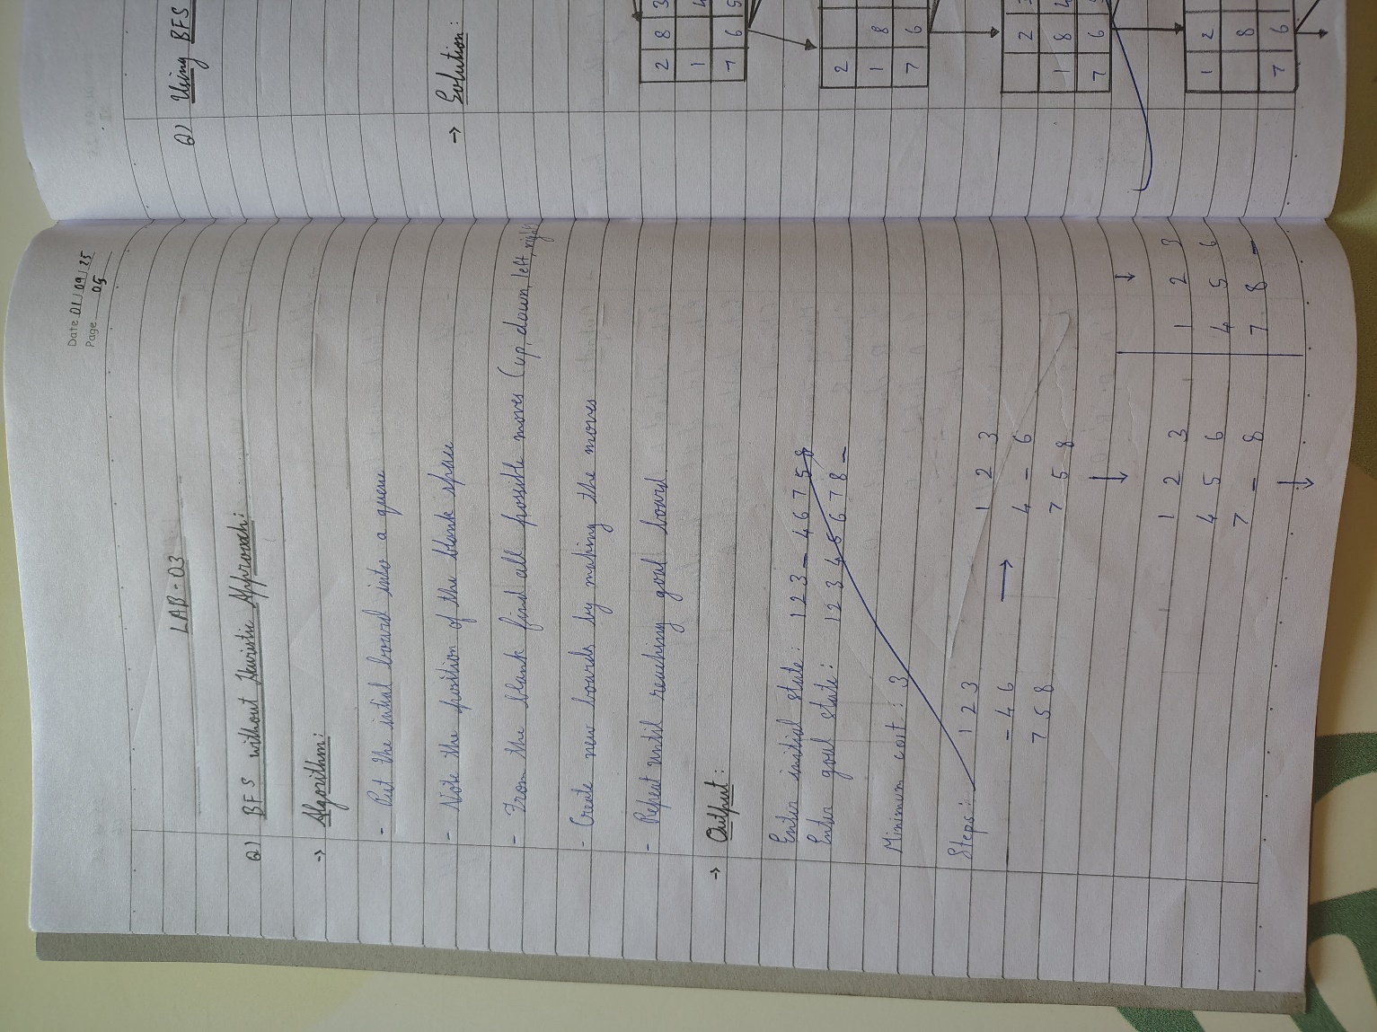 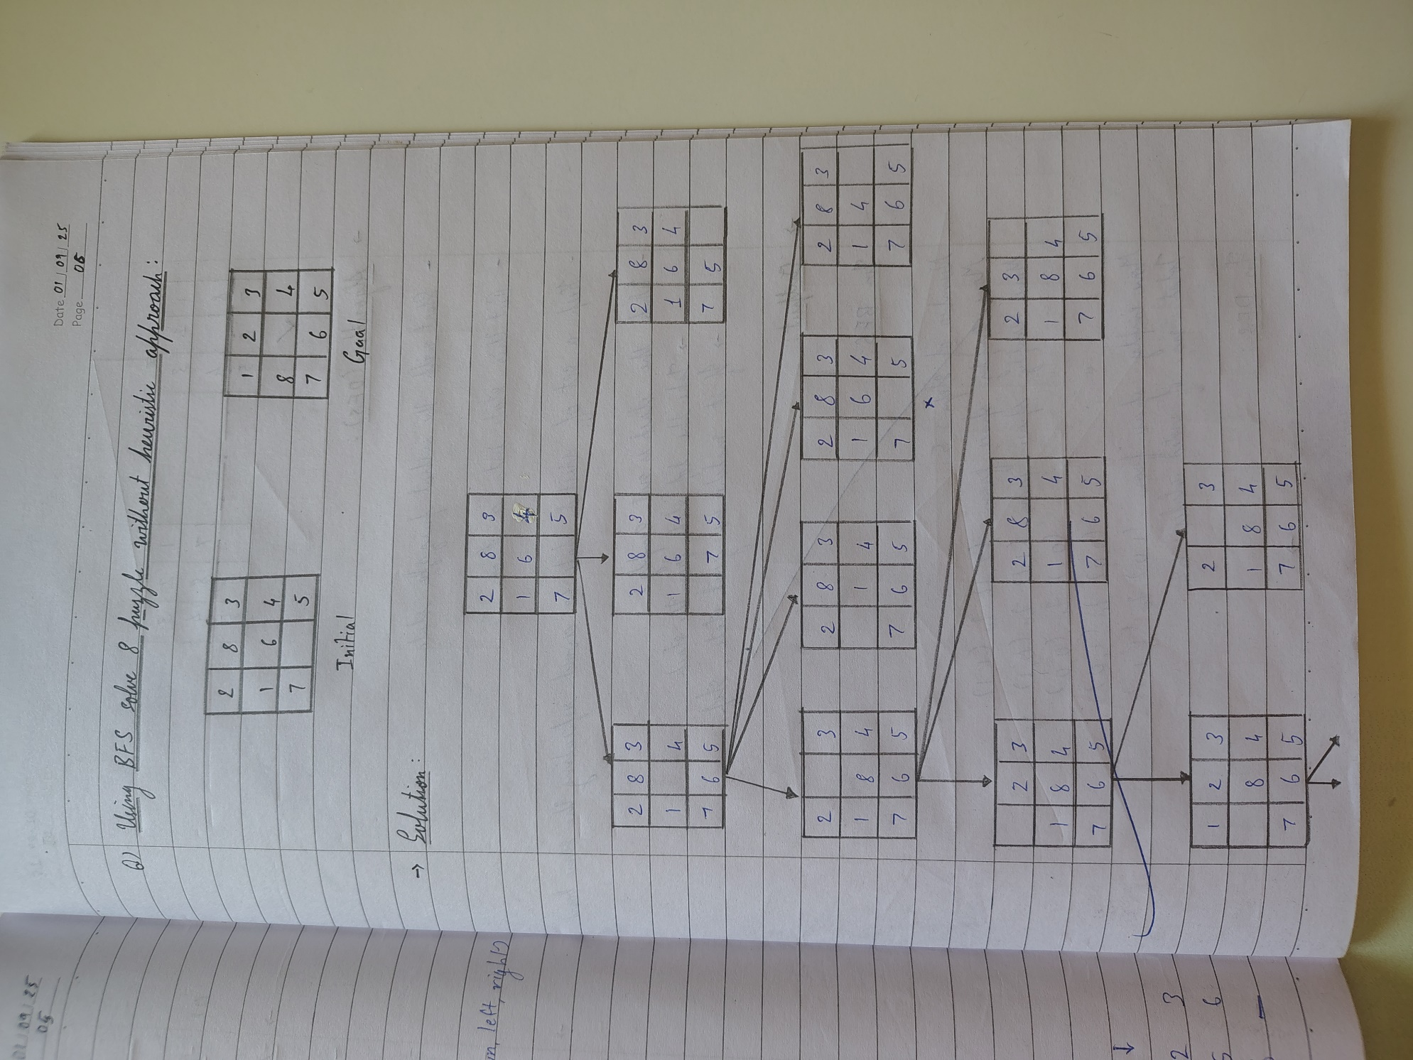 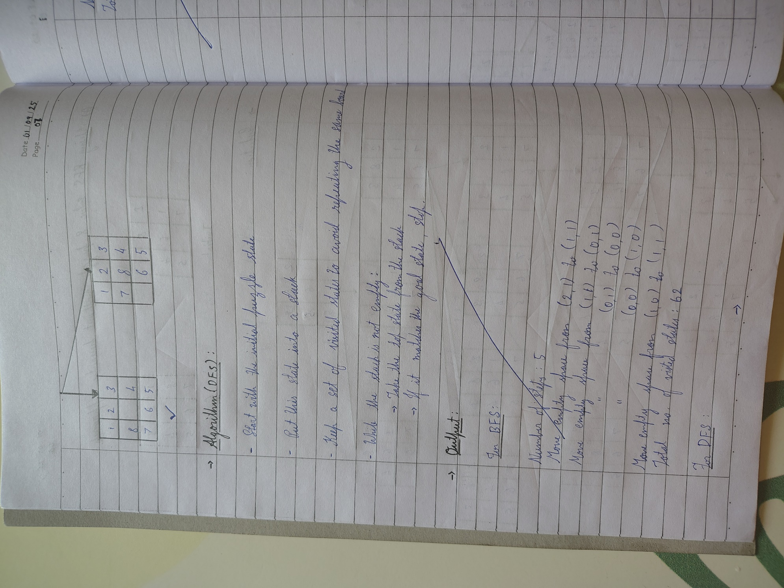

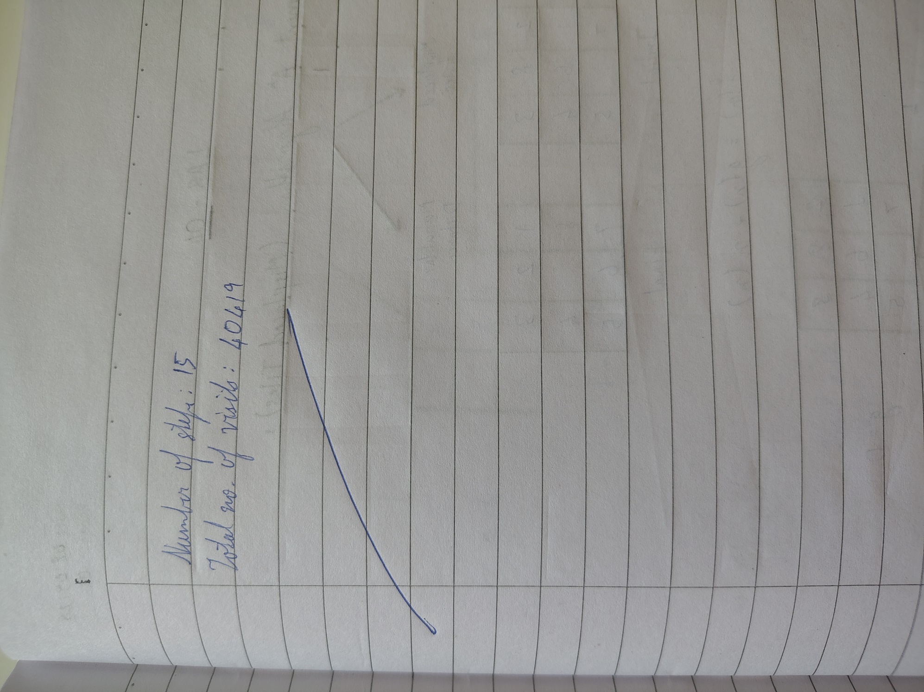

**Code (BFS):**

from collections import deque

GOAL_STATE = (1, 2, 3,

8, 0, 4,

7, 6, 5)

MOVES = {

'Up': (-1, 0),

'Down': (1, 0),

'Left': (0, -1),

'Right': (0, 1)

}

def index_to_pos(index):

return index // 3, index % 3

def pos_to_index(row, col):

return row * 3 + col

def get_neighbors(state):

neighbors = []

zero_index = state.index(0)

zero_row, zero_col = index_to_pos(zero_index)

for move, (dr, dc) in MOVES.items():

new_row, new_col = zero_row + dr, zero_col + dc

if 0 <= new_row < 3 and 0 <= new_col < 3:

new_zero_index = pos_to_index(new_row, new_col)

new_state = list(state)

new_state[zero_index], new_state[new_zero_index] = new_state[new_zero_index], new_state[zero_index]

neighbors.append((tuple(new_state), move))

return neighbors

def bfs(start_state, max_depth=50):

queue = deque([(start_state, [], [start_state])])

visited = set([start_state])

while queue:

state, path_moves, path_states = queue.popleft()

if state == GOAL_STATE:

return path_moves, path_states

if len(path_moves) < max_depth:

for neighbor, move in get_neighbors(state):

if neighbor not in visited:

visited.add(neighbor)

queue.append((neighbor, path_moves + [move], path_states + [neighbor]))

return None, None

def print_puzzle(state):

for i in range(0, 9, 3):

print(state[i:i+3])

print()

name = input("Enter your name: ")

usn = input("Enter your USN: ")

start_state = (2, 8, 3,

1, 6, 4,

7, 0, 5)

print(f"\nSolver started for {name} (USN: {usn})")

print("\nStart State:")

print_puzzle(start_state)

moves, states = bfs(start_state, max_depth=50)

if moves is not None:

print(f"Solution found in {len(moves)} moves!\n")

print("States passed through from start to goal:")

for i, state in enumerate(states):

print(f"Step {i}:")

print_puzzle(state)

print("Moves to solve the puzzle:")

print(moves)

else:

print("No solution found within the depth limit.")

**Code (DFS):**

from collections import deque

GOAL_STATE = (1, 2, 3,

8, 0, 4,

7, 6, 5) *# 0 represents the blank tile*

MOVES = {

'Up': (-1, 0),

'Down': (1, 0),

'Left': (0, -1),

'Right': (0, 1)

}

def index_to_pos(index):

return index // 3, index % 3

def pos_to_index(row, col):

return row * 3 + col

def get_neighbors(state):

neighbors = []

zero_index = state.index(0)

zero_row, zero_col = index_to_pos(zero_index)

for move, (dr, dc) in MOVES.items():

new_row, new_col = zero_row + dr, zero_col + dc

if 0 <= new_row < 3 and 0 <= new_col < 3:

new_zero_index = pos_to_index(new_row, new_col)

new_state = list(state)

new_state[zero_index], new_state[new_zero_index] = new_state[new_zero_index], new_state[zero_index]

neighbors.append((tuple(new_state), move))

return neighbors

def dfs(start_state, max_depth=50):

stack = [(start_state, [], [start_state], 0)]

visited = set()

while stack:

state, path_moves, path_states, depth = stack.pop()

if state == GOAL_STATE:

return path_moves, path_states

if state in visited:

continue

visited.add(state)

if depth < max_depth:

for neighbor, move in get_neighbors(state):

if neighbor not in visited:

stack.append((neighbor, path_moves + [move], path_states + [neighbor], depth + 1))

return None, None

def print_puzzle(state):

for i in range(0, 9, 3):

print(state[i:i+3])

print()

name = input("Enter your name: ")

usn = input("Enter your USN: ")

start_state = (2, 8, 3,

1, 6, 4,

7, 0, 5)

print(f"\nSolver started for {name} (USN: {usn})")

print("\nStart State:")

print_puzzle(start_state)

moves, states = dfs(start_state, max_depth=30)

if moves is not None:

print(f"Solution found in {len(moves)} moves!\n")

print("States passed through from start to goal:")

for i, state in enumerate(states):

print(f"Step {i}:")

print_puzzle(state)

print("Moves to solve the puzzle:")

print(moves)

else:

print("No solution found within the depth limit.")

**Output (BFS):**

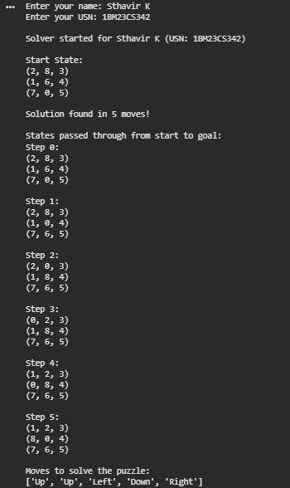

**Output (DFS):**

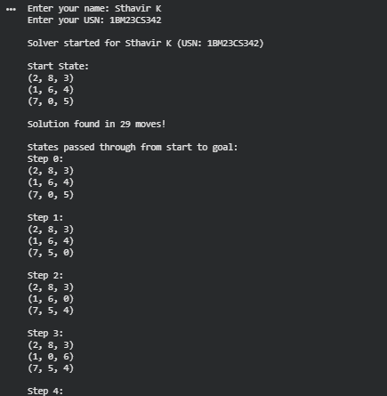

**Program 3**

Implement A* search algorithm

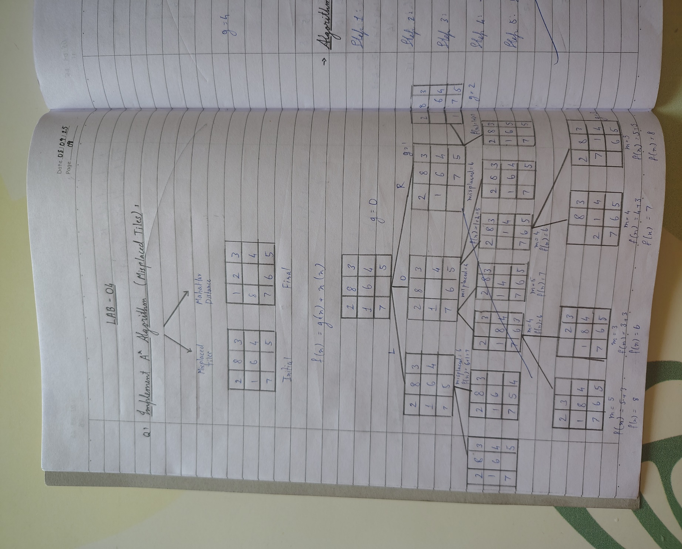

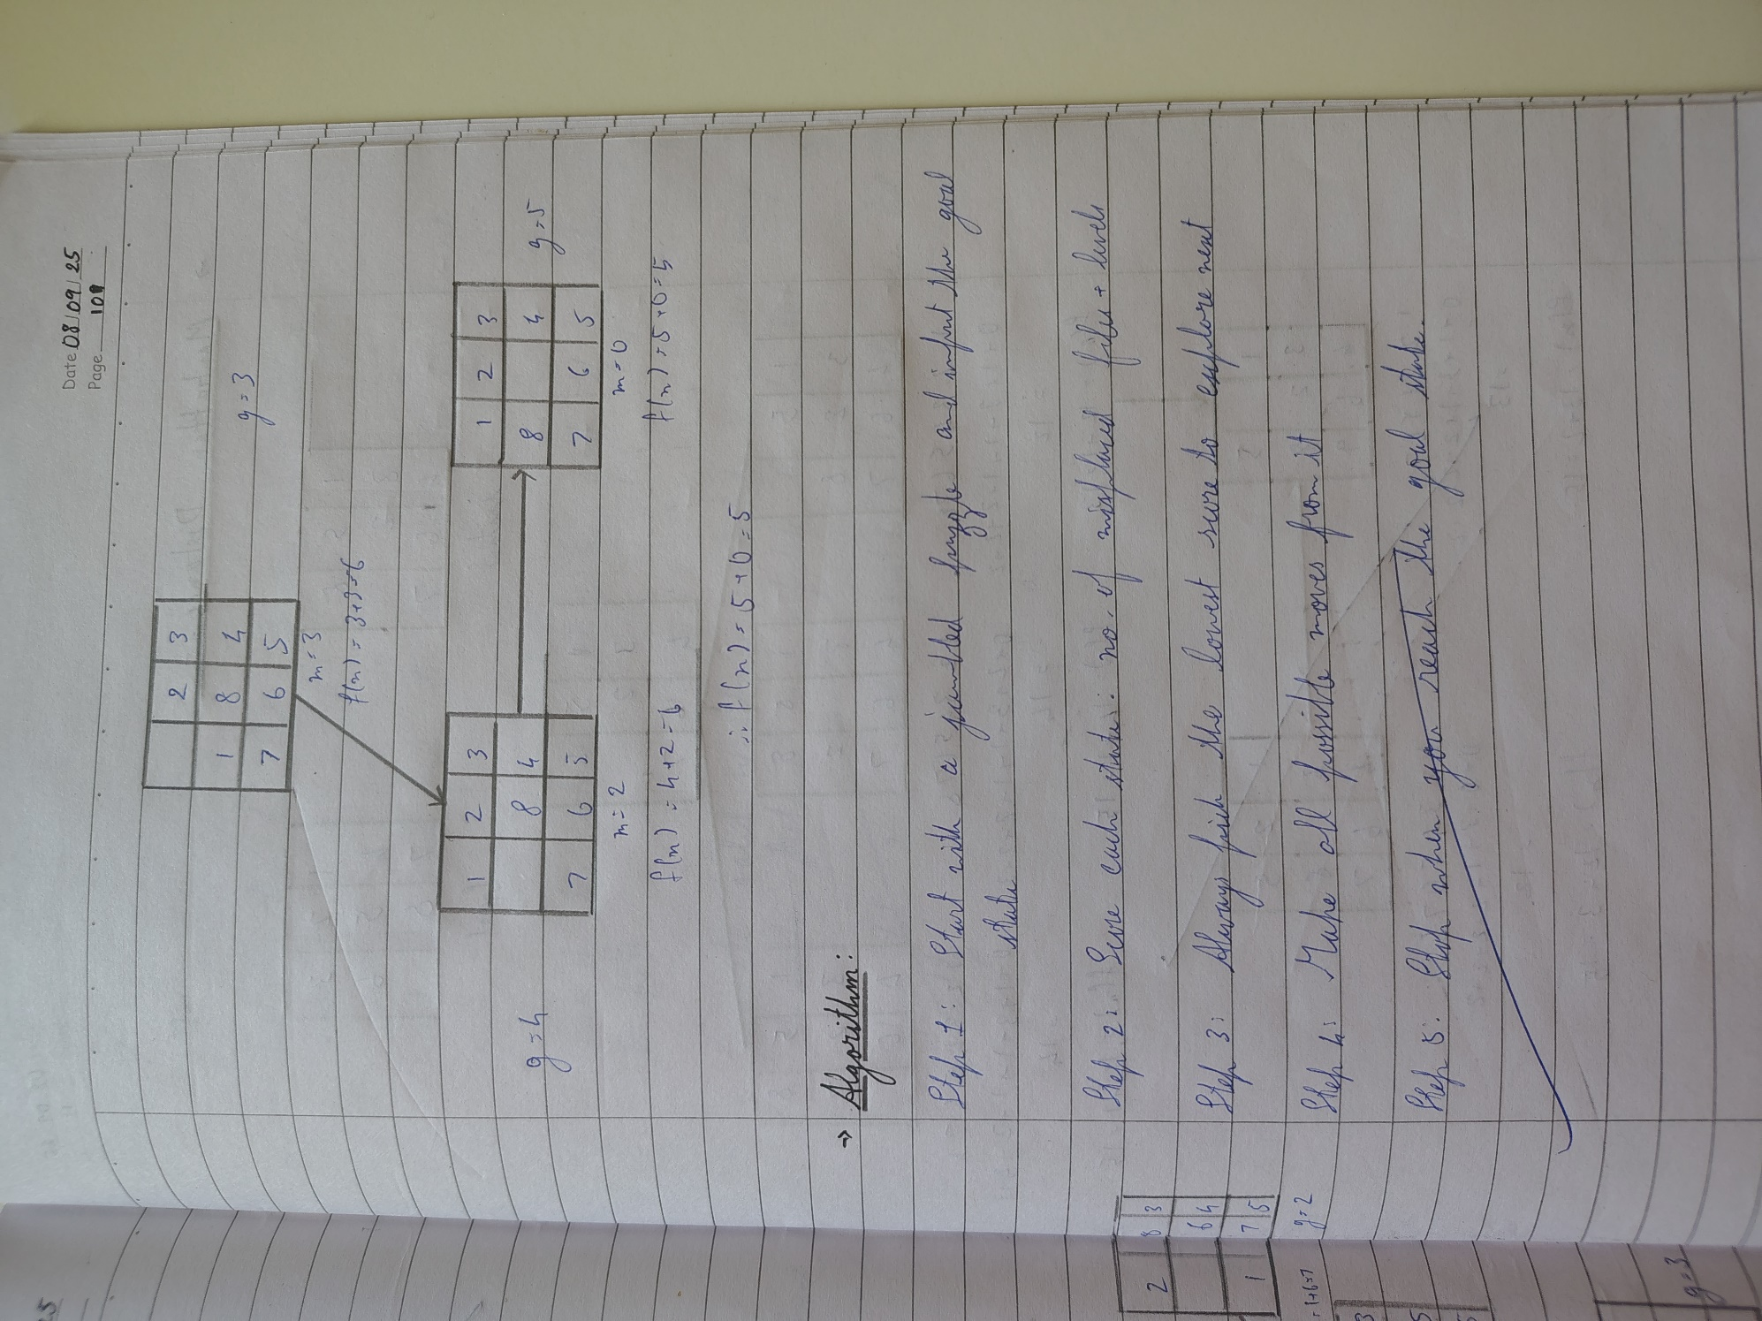

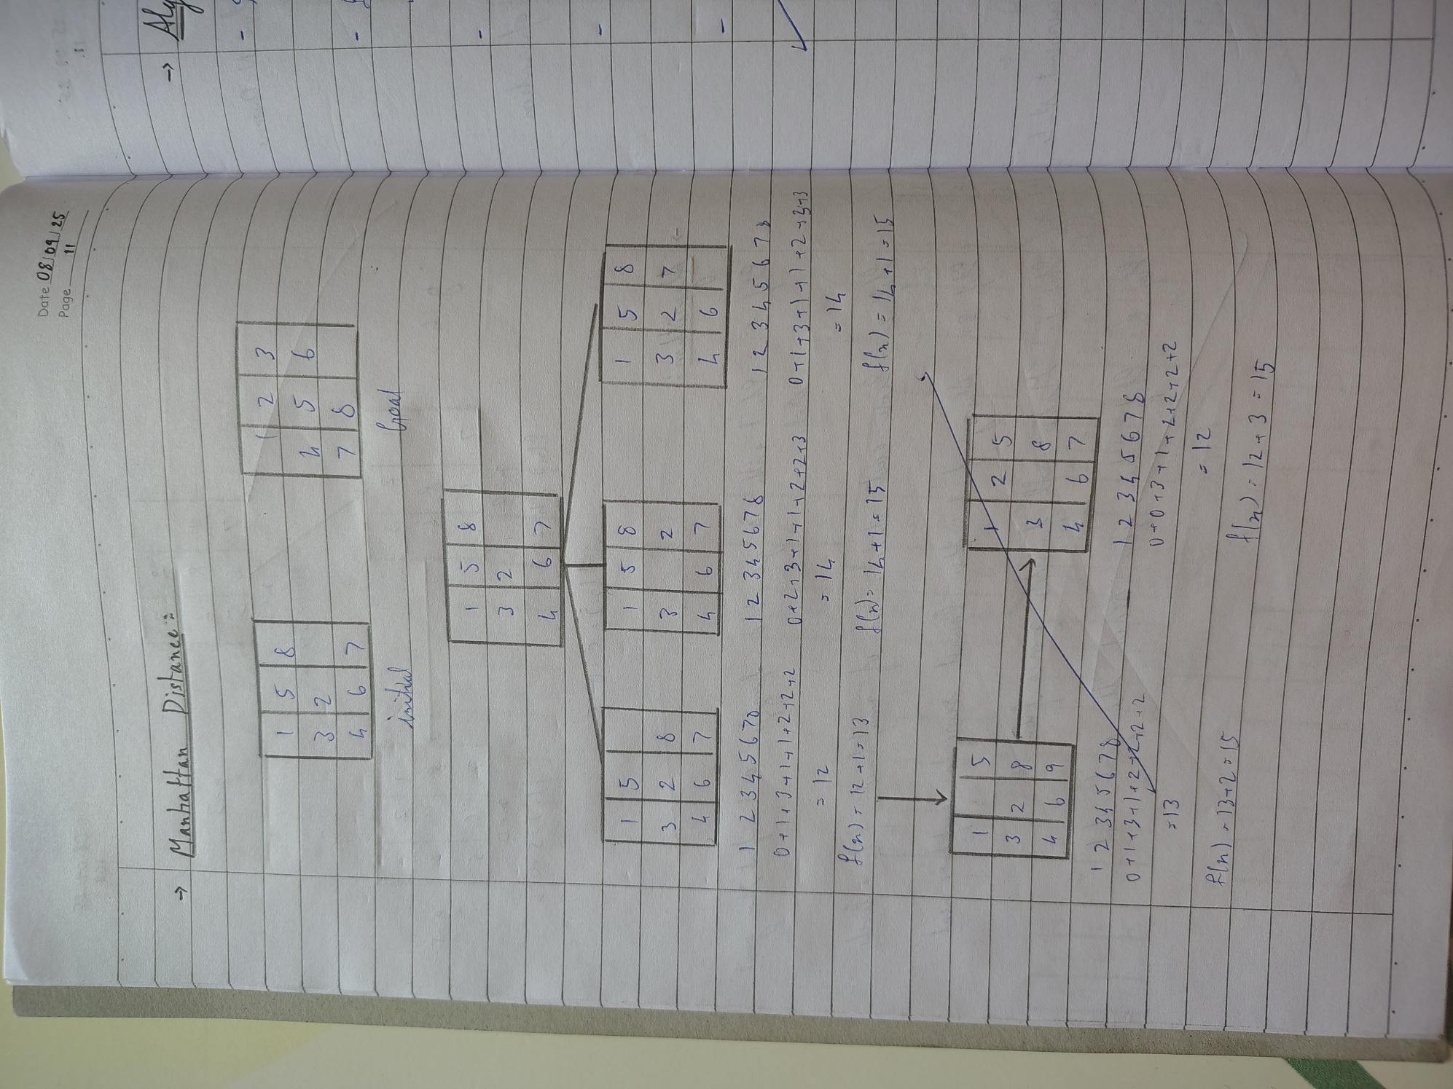

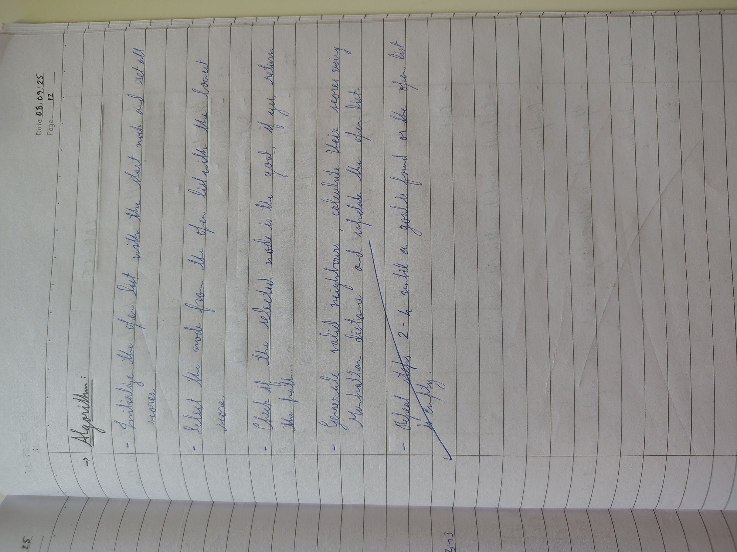

**Code (Misplaced Tiles):**

import copy

import heapq

NAME = "Sthavir K"

USN = "1BM23CS342"

print(f"Name: {NAME}")

print(f"USN : {USN}\n")

goal_state = [[1, 2, 3],

[8, 0, 4],

[7, 6, 5]]

def heuristic_misplaced(current_state):

misplaced = 0

for i in range(3):

for j in range(3):

if current_state[i][j] != 0 and current_state[i][j] != goal_state[i][j]:

misplaced += 1

return misplaced

def is_goal(state):

return state == goal_state

def find_blank(state):

for i in range(3):

for j in range(3):

if state[i][j] == 0:

return i, j

def get_neighbors(state):

neighbors = []

x, y = find_blank(state)

directions = [(-1,0), (1,0), (0,-1), (0,1)]

for dx, dy in directions:

nx, ny = x + dx, y + dy

if 0 <= nx < 3 and 0 <= ny <3:

new_state = copy.deepcopy(state)

new_state[x][y], new_state[nx][ny] = new_state[nx][ny], new_state[x][y]

neighbors.append(new_state)

return neighbors

def a_star_misplaced(initial_state):

open_list = []

heapq.heappush(open_list, (heuristic_misplaced(initial_state), 0, initial_state, []))

visited = set()

while open_list:

heuristic, g, current_state, path = heapq.heappop(open_list)

state_id = str(current_state)

if state_id in visited:

continue

visited.add(state_id)

if is_goal(current_state):

return path + [current_state]

for neighbor in get_neighbors(current_state):

heapq.heappush(open_list, (heuristic_misplaced(neighbor) + g + 1, g + 1, neighbor, path + [current_state]))

return None

initial_state = [[2, 8, 3],

[1, 6, 4],

[7, 0, 5]]

solution = a_star_misplaced(initial_state)

print("\nSolution Steps:\n")

for step in solution:

for row in step:

print(row)

print()

**Code (Manhattan Distance):**

import copy

import heapq

NAME = "Sthavir K"

USN = "1BM23CS342"

print(f"Name: {NAME}")

print(f"USN : {USN}\n")

goal_state = [[1, 2, 3],

[8, 0, 4],

[7, 6, 5]]

def heuristic_manhattan(current_state):

distance = 0

for i in range(3):

for j in range(3):

value = current_state[i][j]

if value != 0:

goal_x, goal_y = divmod(value - 1, 3)

distance += abs(i - goal_x) + abs(j - goal_y)

return distance

def is_goal(state):

return state == goal_state

def find_blank(state):

for i in range(3):

for j in range(3):

if state[i][j] == 0:

return i, j

def get_neighbors(state):

neighbors = []

x, y = find_blank(state)

directions = [(-1,0), (1,0), (0,-1), (0,1)]

for dx, dy in directions:

nx, ny = x + dx, y + dy

if 0 <= nx < 3 and 0 <= ny <3:

new_state = copy.deepcopy(state)

new_state[x][y], new_state[nx][ny] = new_state[nx][ny], new_state[x][y]

neighbors.append(new_state)

return neighbors

def a_star_manhattan(initial_state):

open_list = []

heapq.heappush(open_list, (heuristic_manhattan(initial_state), 0, initial_state, []))

visited = set()

while open_list:

heuristic, g, current_state, path = heapq.heappop(open_list)

state_id = str(current_state)

if state_id in visited:

continue

visited.add(state_id)

if is_goal(current_state):

return path + [current_state]

for neighbor in get_neighbors(current_state):

heapq.heappush(open_list, (heuristic_manhattan(neighbor) + g + 1, g + 1, neighbor, path + [current_state]))

return None

*# Initial state example*

initial_state = [[2, 8, 3],

[1, 6, 4],

[7, 0, 5]]

solution = a_star_manhattan(initial_state)

print("\nSolution Steps:\n")

for step in solution:

for row in step:

print(row)

print()

**Output (Misplaced Tiles):**

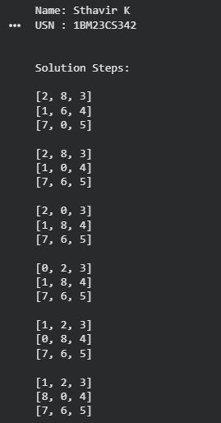

**Output (Manhattan Distance):**

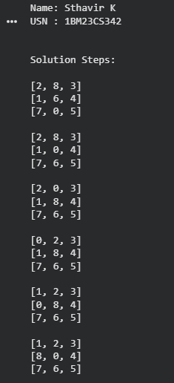

**Program 4**

Implement Hill Climbing search algorithm to solve N-Queens problem

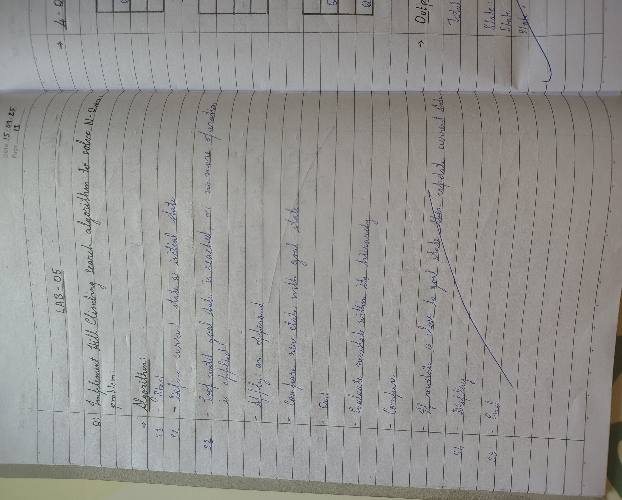

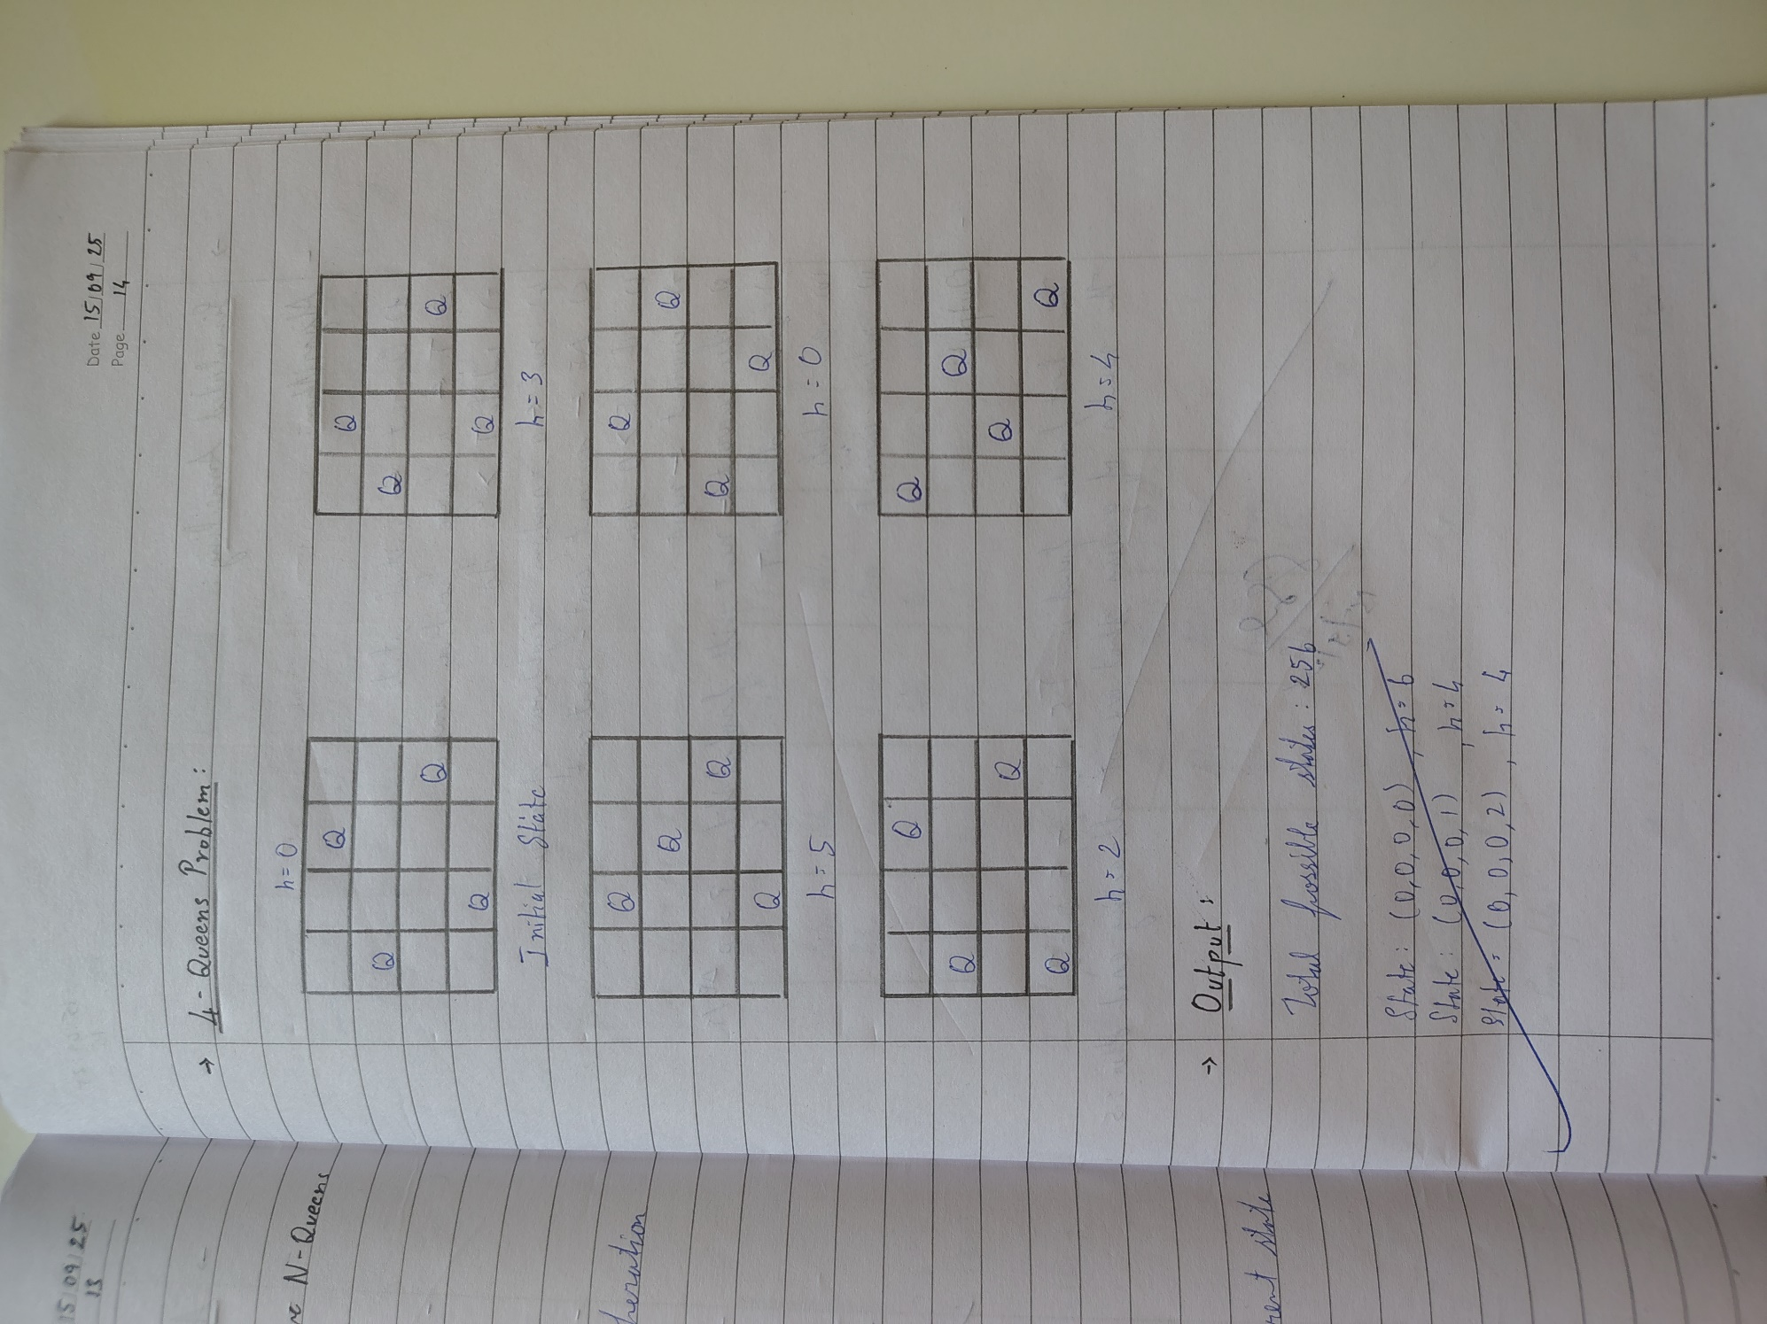

**Code:**

import random

def calculate_cost(state):

cost = 0

n = len(state)

for i in range(n):

for j in range(i+1, n):

if state[i] == state[j]:

cost += 1

if abs(state[i] - state[j]) == abs(i - j):

cost += 1

return cost

def random_state(n):

return [random.randint(0, n-1) for _ in range(n)]

def get_best_neighbor(state):

n = len(state)

best_state = state[:]

best_cost = calculate_cost(state)

for col in range(n):

for row in range(n):

if state[col] != row:

new_state = state[:]

new_state[col] = row

new_cost = calculate_cost(new_state)

if new_cost < best_cost:

best_cost = new_cost

best_state = new_state

return best_state, best_cost

def hill_climbing(n):

current = random_state(n)

current_cost = calculate_cost(current)

while True:

neighbor, neighbor_cost = get_best_neighbor(current)

if neighbor_cost < current_cost:

current, current_cost = neighbor, neighbor_cost

else:

break

return current, current_cost

solution, cost = hill_climbing(4)

print("Name: Sthavir K")

print("USN : 1BM23CS342")

print("\nHill Climbing for 4-Queens Problem")

print("Final State (row positions per column):", solution)

print("Final Cost (0 means solved):", cost)

if cost == 0:

print("Solution Found: Queens are safe!")

else:

print(" Stuck in Local Optimum (Not a solution)")

**Output:**

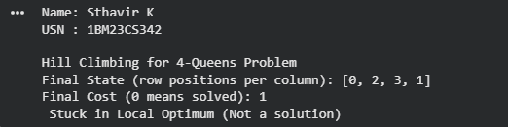

**Program 5**

Simulated Annealing to Solve 8-Queens problem

**Algorithm:**

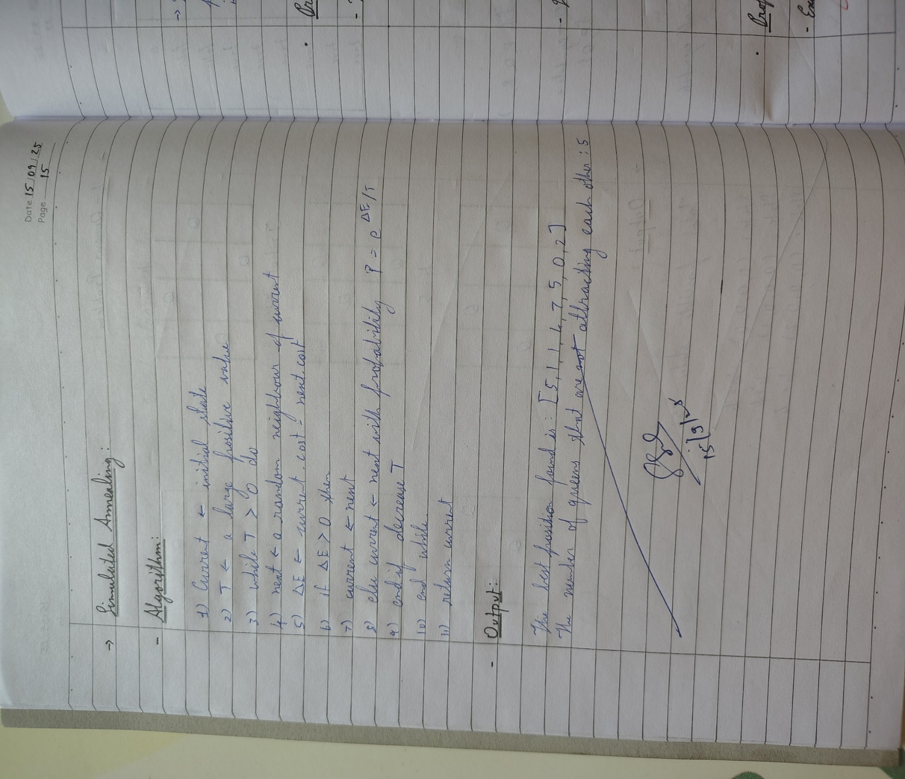

**Code:**

import random

import math

def calculate_cost(state):

cost = 0

n = len(state)

for i in range(n):

for j in range(i+1, n):

if state[i] == state[j]:

cost += 1

if abs(state[i] - state[j]) == abs(i - j):

cost += 1

return cost

def random_state(n):

return [random.randint(0, n-1) for _ in range(n)]

def get_neighbor(state):

n = len(state)

neighbor = state[:]

col = random.randint(0, n-1)

row = random.randint(0, n-1)

neighbor[col] = row

return neighbor

def simulated_annealing(n, max_steps=100000, start_temp=100, cooling_rate=0.99):

current = random_state(n)

current_cost = calculate_cost(current)

T = start_temp

for step in range(max_steps):

if current_cost == 0:

break

neighbor = get_neighbor(current)

neighbor_cost = calculate_cost(neighbor)

delta = neighbor_cost - current_cost

if delta < 0 or random.uniform(0, 1) < math.exp(-delta / T):

current, current_cost = neighbor, neighbor_cost

T = T * cooling_rate

if T < 1e-5:

break

return current, current_cost

solution, cost = simulated_annealing(8)

print("Name: Sthavir K")

print("USN : 1BM23CS342")

print("\nSimulated Annealing for 8-Queens Problem")

print("Final State (row positions per column):", solution)

print("Final Cost (0 means solved):", cost)

if cost == 0:

print("Solution Found: Queens are safe!")

else:

print("Stuck in Local Optimum (Not a solution)")

**Output:**

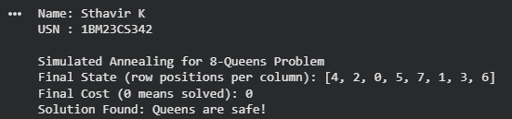

**Program 6**

Create a knowledge base using propositional logic and show that the given query entails the knowledge base or not

**Algorithm:**

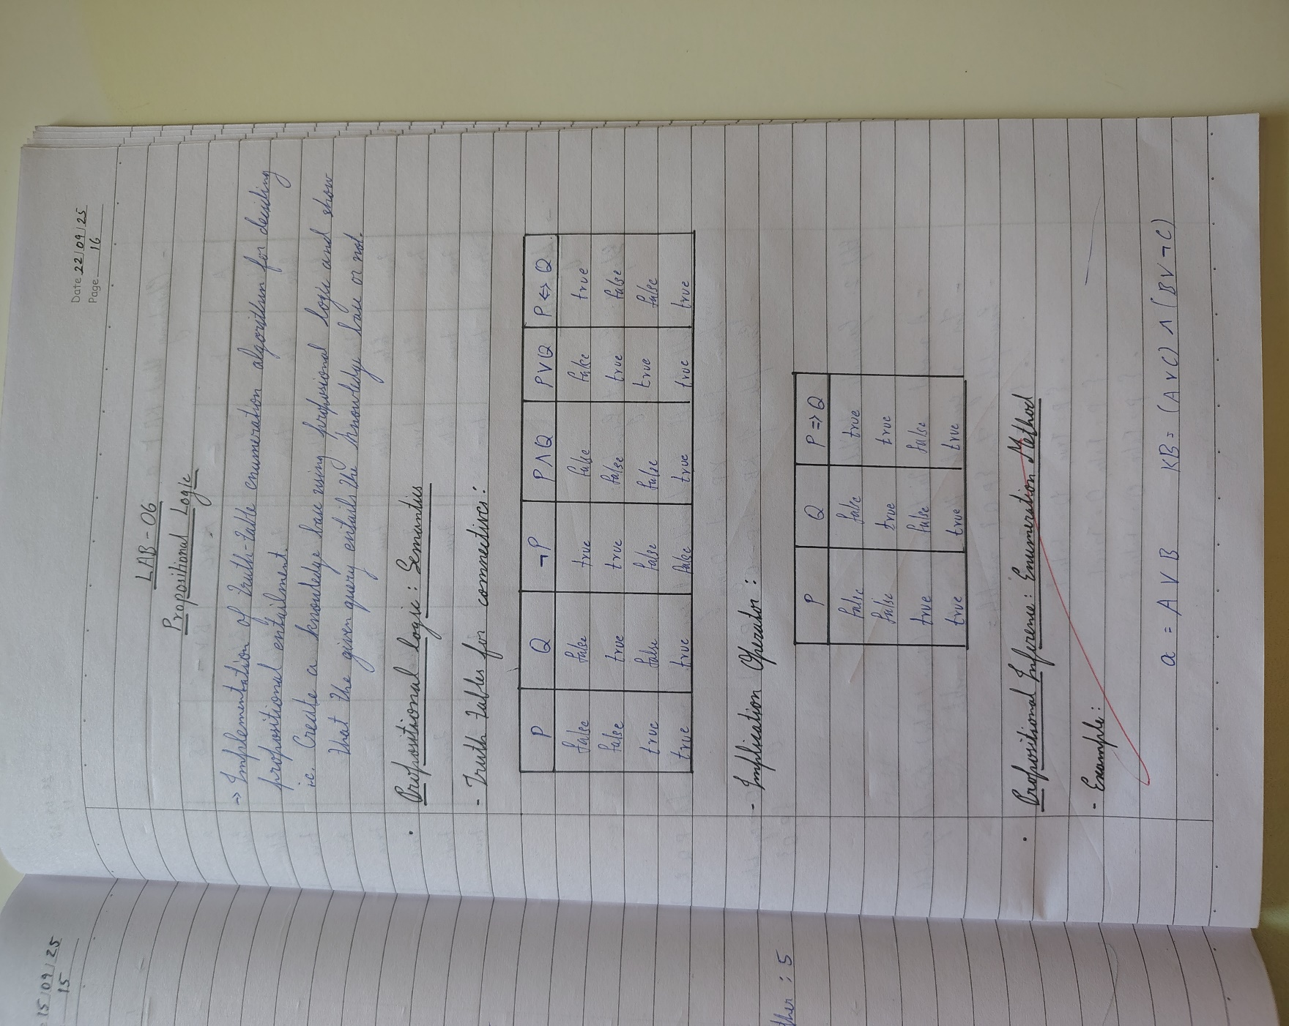

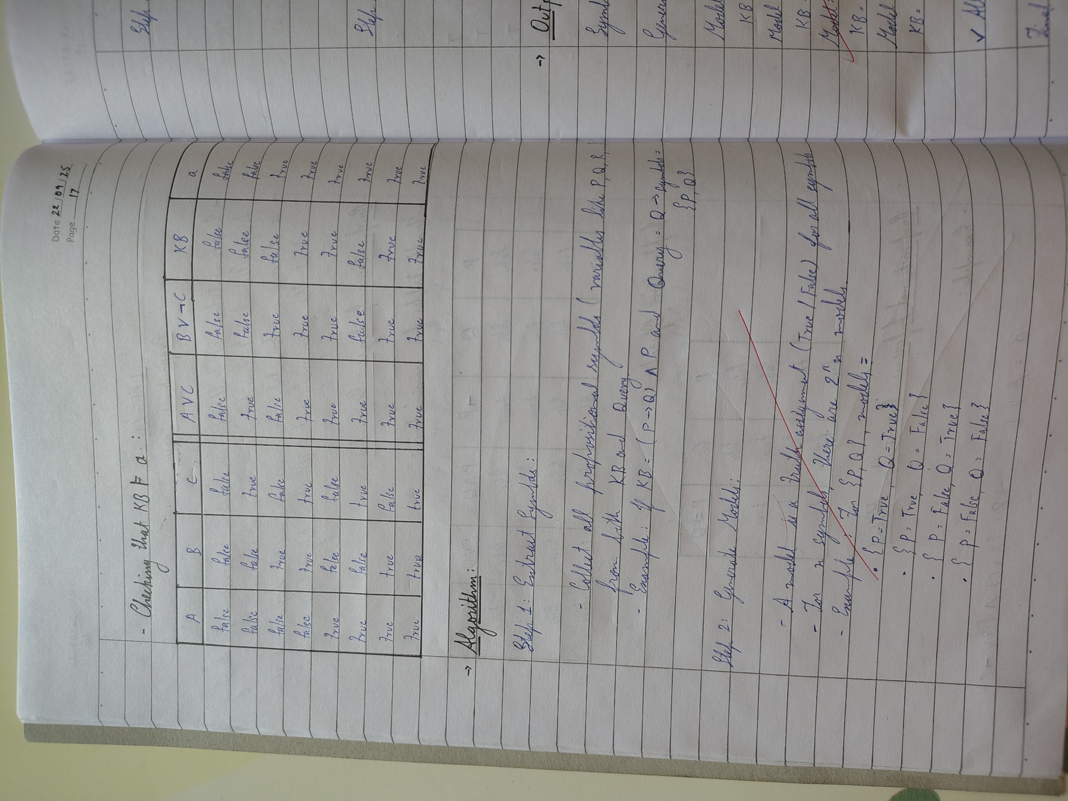

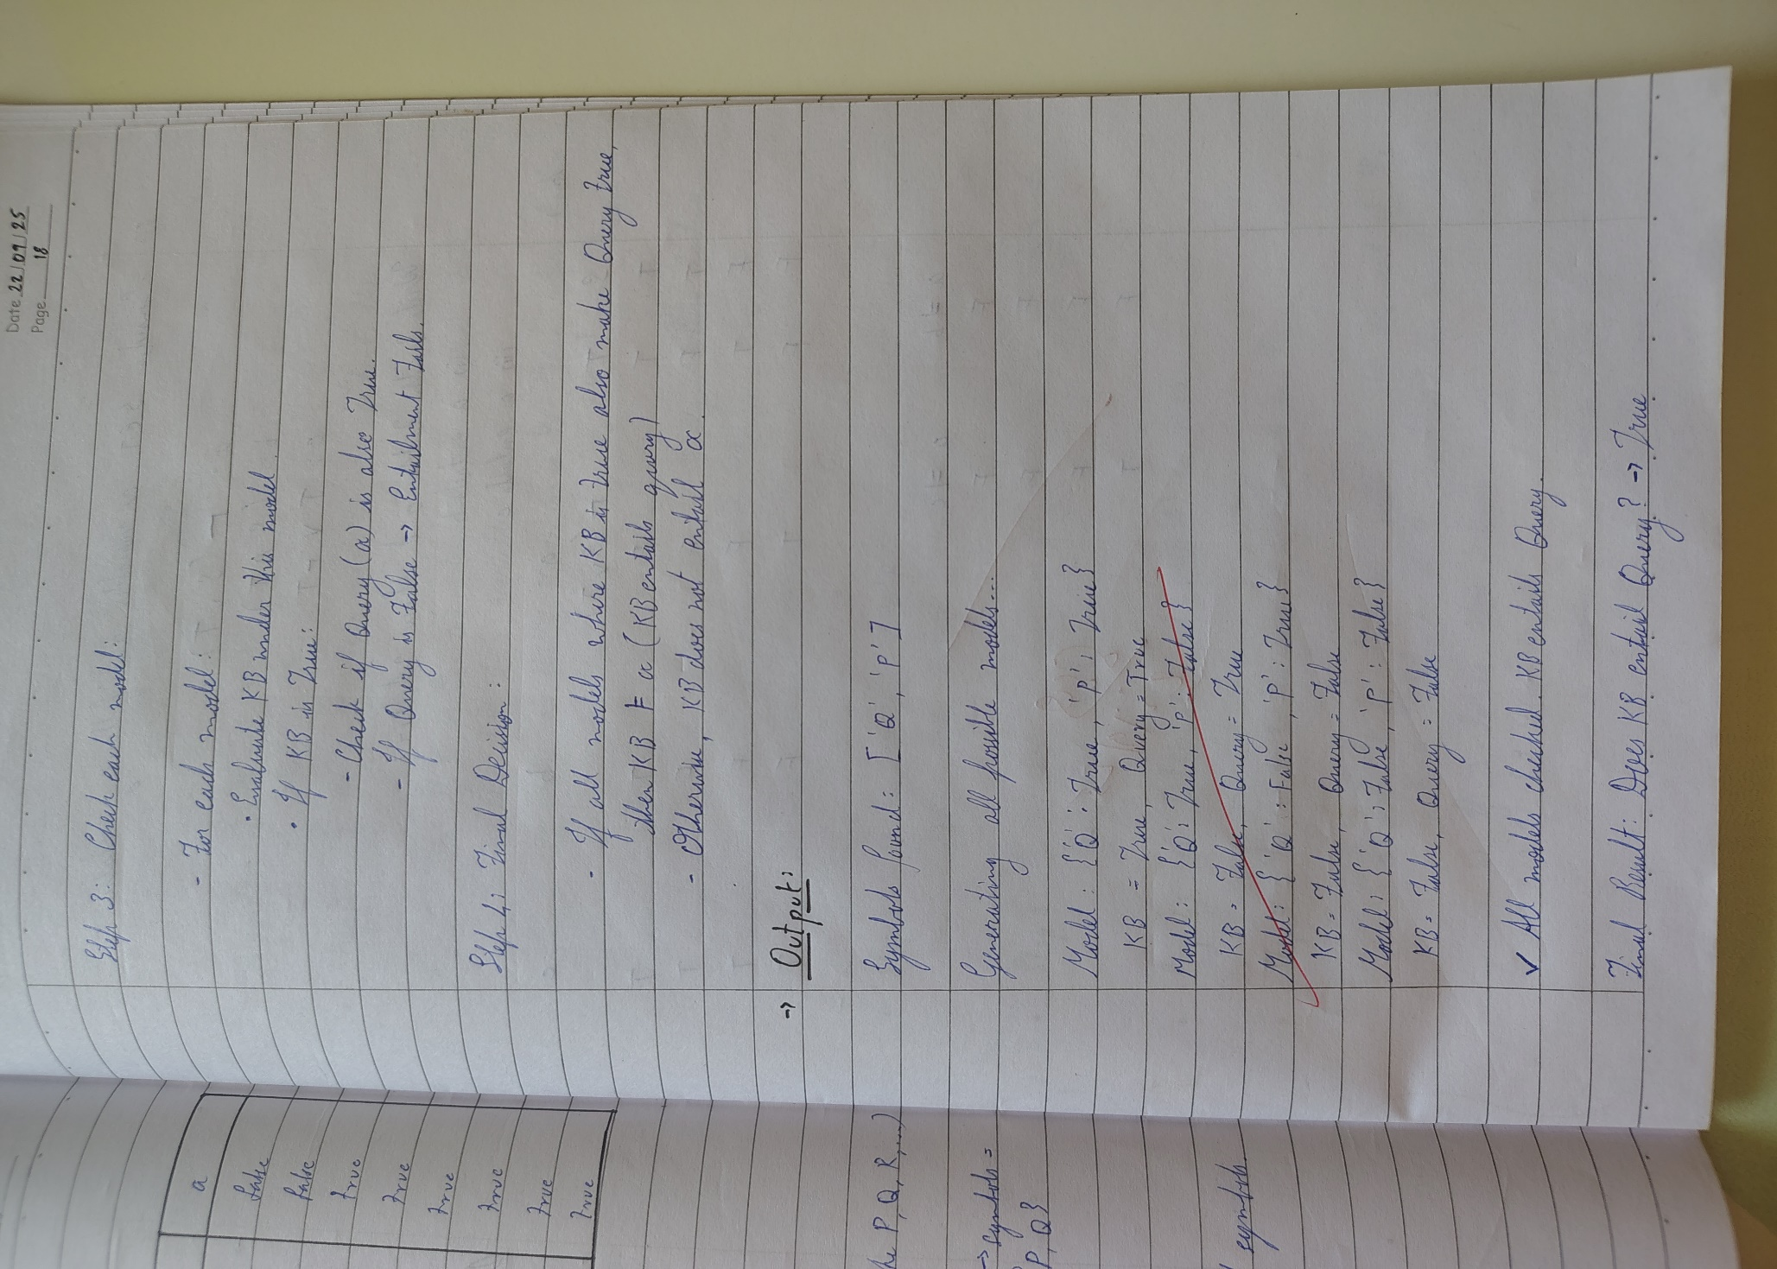

**Code:**

import itertools

def pl_true(expr, model):

    if isinstance(expr, str):

        return model[expr]

    elif isinstance(expr, tuple):

        op = expr[0]

        if op == "not":

            return not pl_true(expr[1], model)

        elif op == "and":

            return pl_true(expr[1], model) and pl_true(expr[2], model)

        elif op == "or":

            return pl_true(expr[1], model) or pl_true(expr[2], model)

        elif op == "implies":

            return (not pl_true(expr[1], model)) or pl_true(expr[2], model)

    return False

def get_symbols(expr):

    if isinstance(expr, str):

        return {expr}

    elif isinstance(expr, tuple):

        return get_symbols(expr[1]) | (get_symbols(expr[2]) if len(expr) > 2 else set())

    return set()

def tt_entails_print(KB, query):

    symbols = list(get_symbols(KB) | get_symbols(query))

    all_models = list(itertools.product([True, False], repeat=len(symbols)))

    entailment = True

    print("\nTruth Table Evaluation:")

    print("-" * 50)

    print("Model".ljust(20), "KB".ljust(10), "Query".ljust(10))

    print("-" * 50)

    for values in all_models:

        model = dict(zip(symbols, values))

        kb_val = pl_true(KB, model)

        q_val = pl_true(query, model)

        print(str(model).ljust(20), str(kb_val).ljust(10), str(q_val).ljust(10))

        if kb_val and not q_val:

            entailment = False

    print("-" * 50)

    return entailment

KB = ("and", ("implies", "P", "Q"), "P")

query = "Q"

result = tt_entails_print(KB, query)

print("\nName: Sthavir K")

print("USN : 1BM23CS342")

print("\nKnowledge Base: (P → Q) and (P)")

print("Query: Q")

print("Does KB entail Query? :", "YES " if result else "NO ")

**Output:**

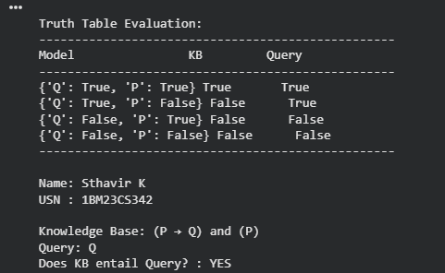

**Program 7**

Implement unification in first order logic:

**Algorithm:**

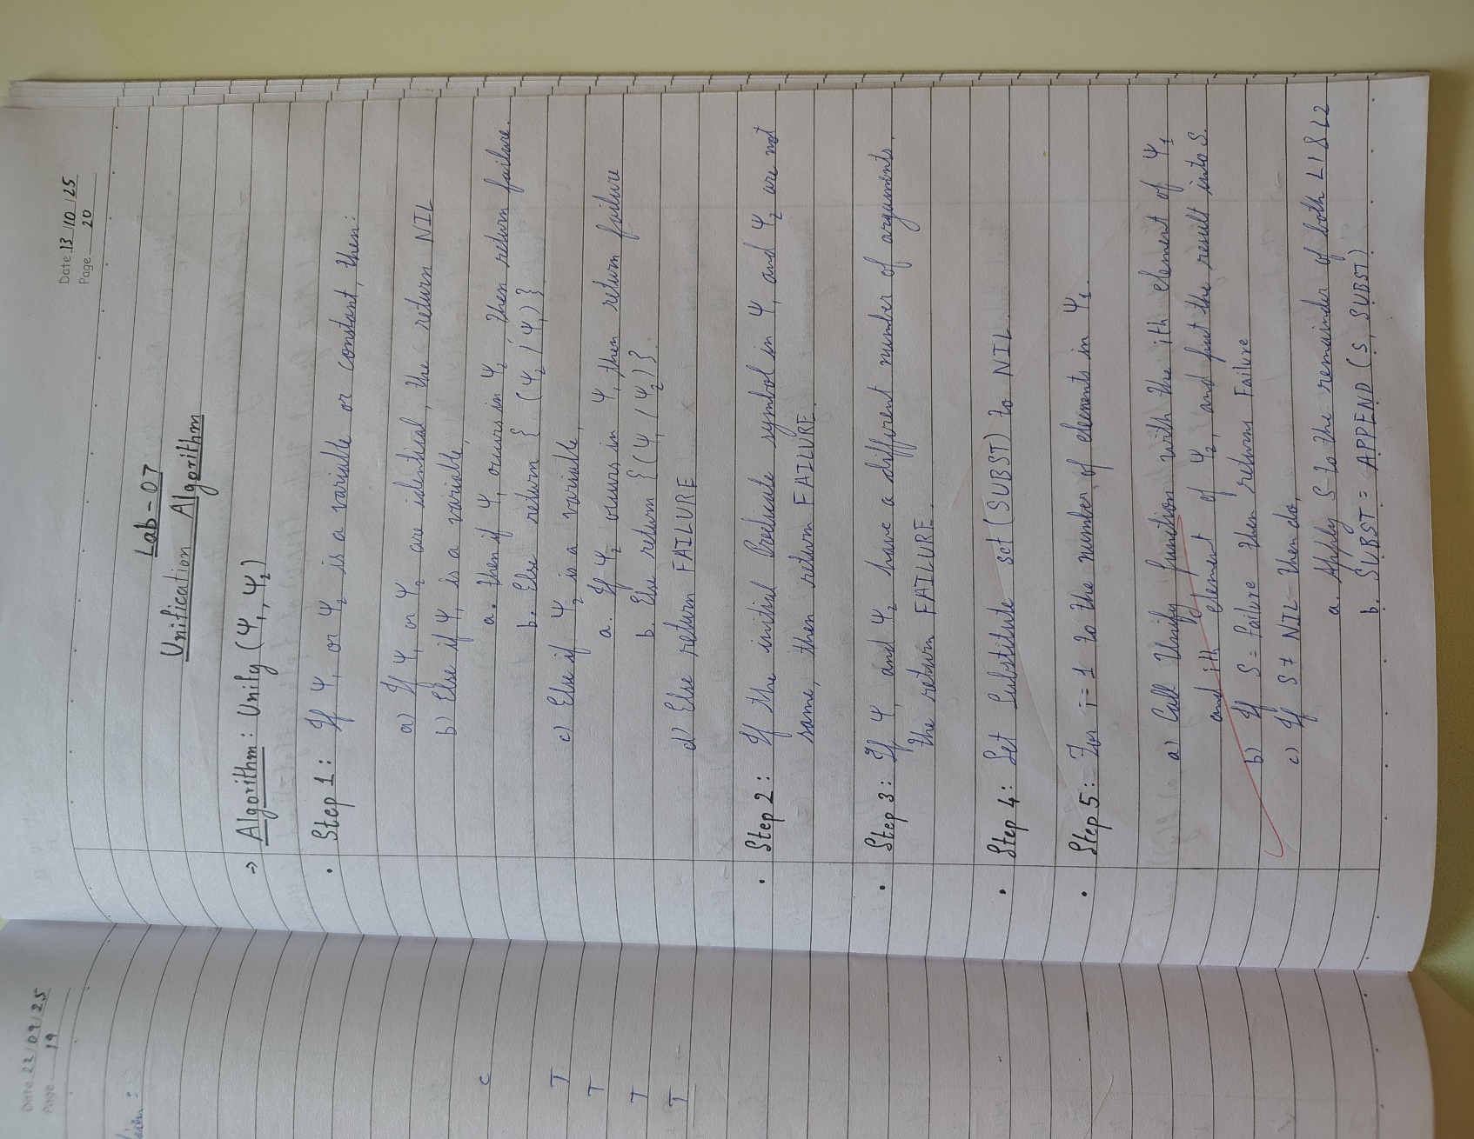

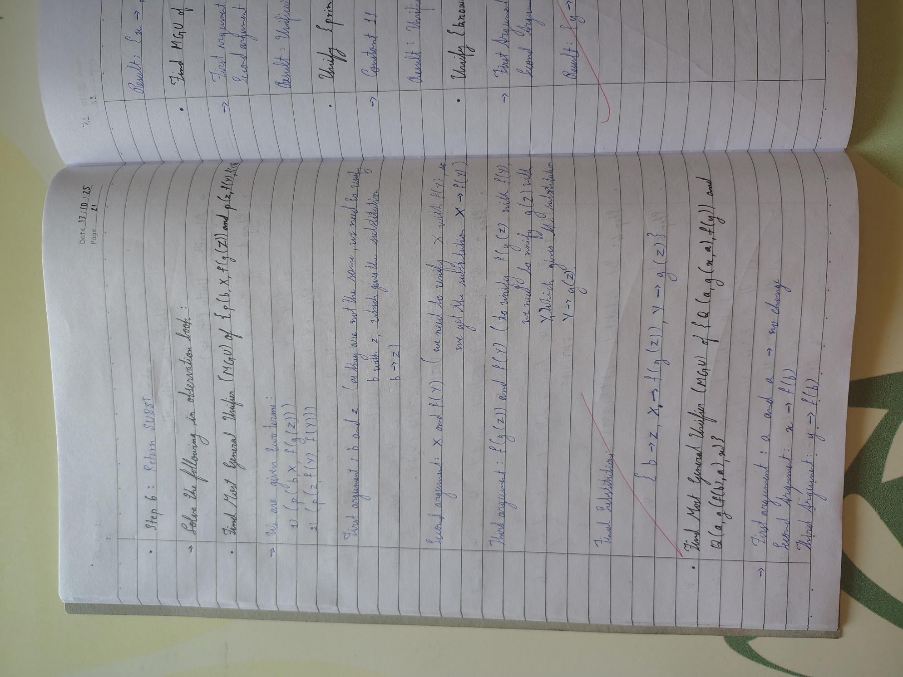

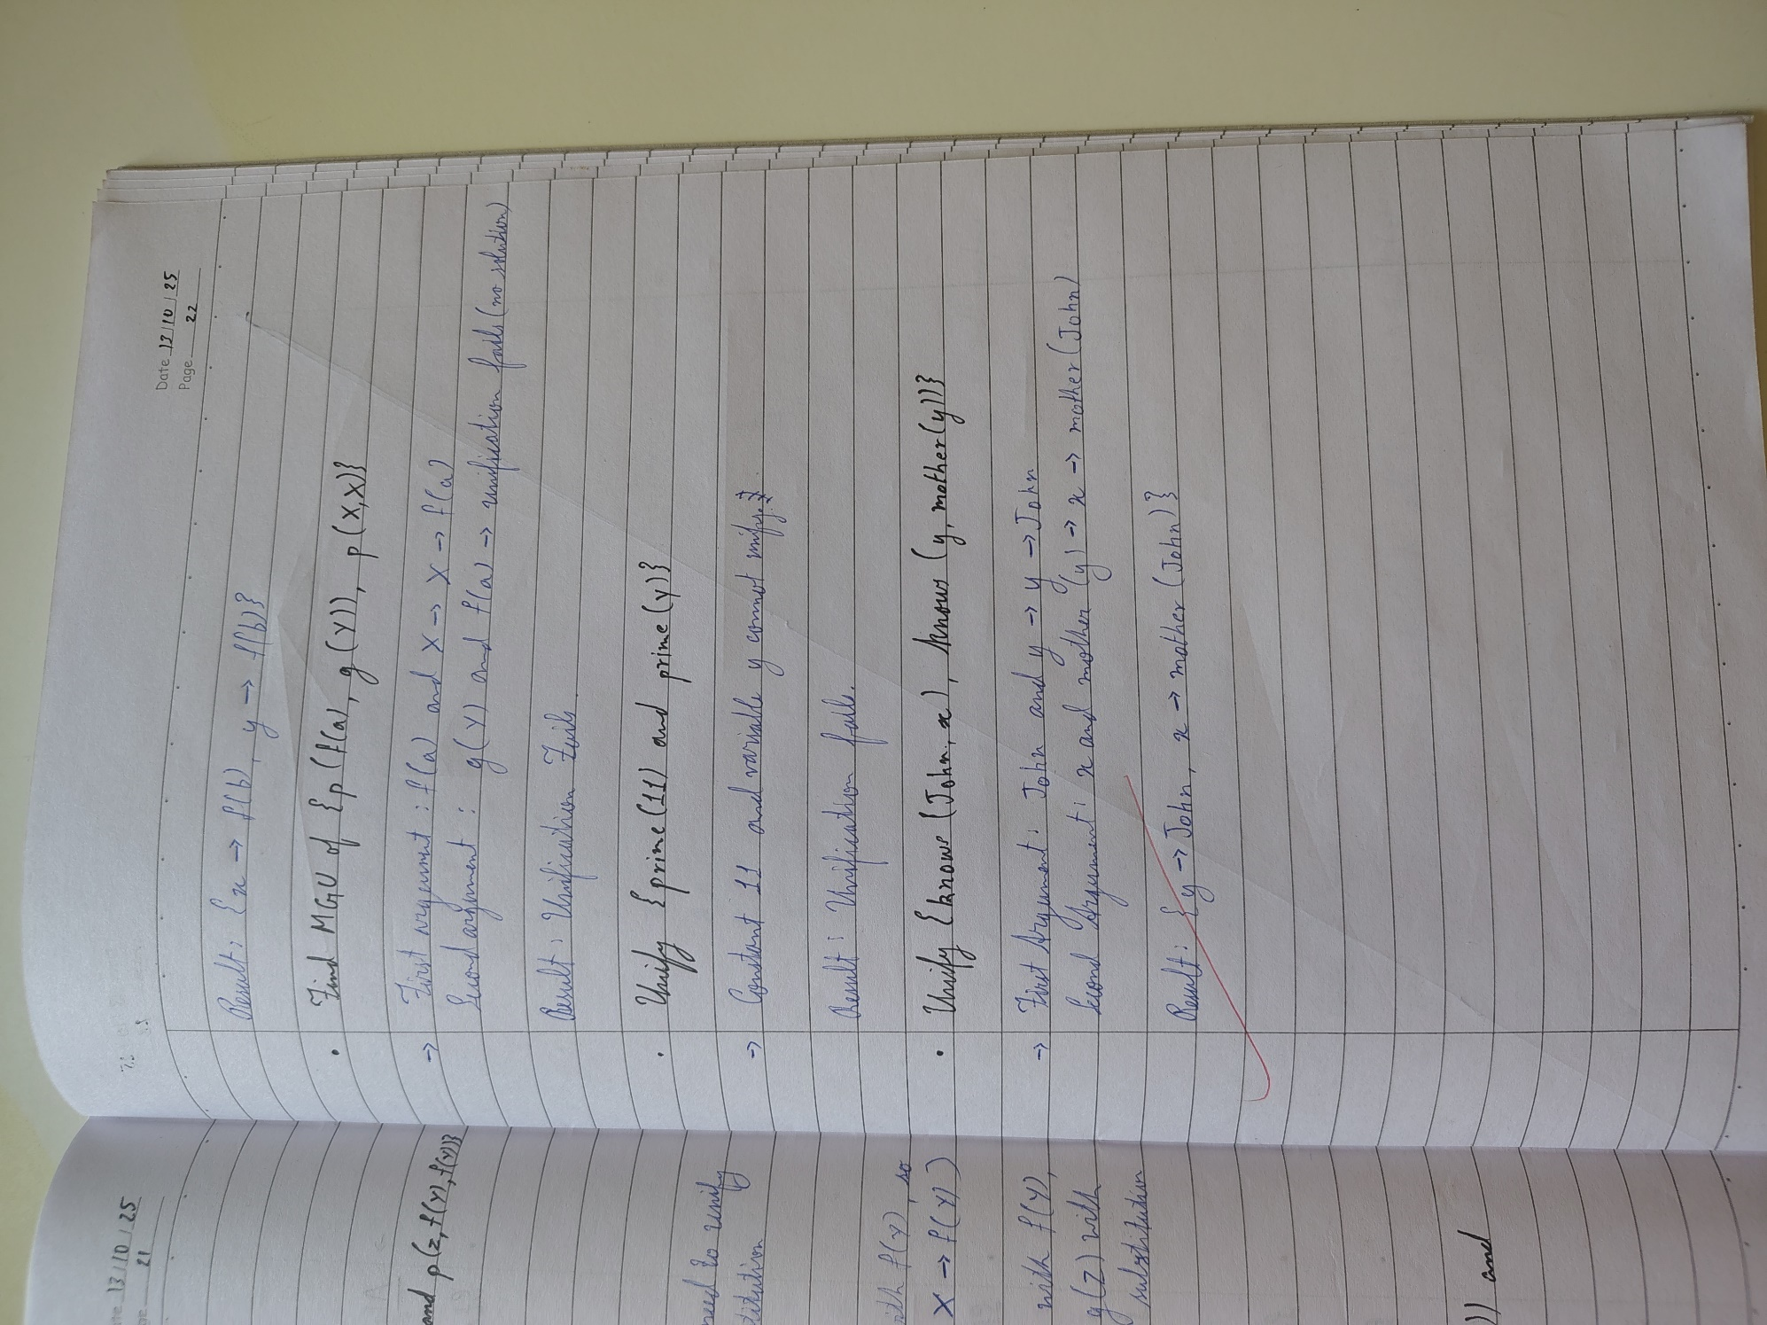

**Code:**

import json

# --- Helper Functions for Term Manipulation ---

def is_variable(term):

"""Checks if a term is a variable (a single capital letter string)."""

return isinstance(term, str) and len(term) == 1 and 'A' <= term[0] <= 'Z'

def occurs_check(variable, term, sigma):

"""

Checks if 'variable' occurs anywhere in 'term' under the current substitution 'sigma'.

This prevents infinite recursion (e.g., unifying X with f(X)).

"""

term = apply_substitution(term, sigma) # Check the substituted term

if term == variable:

return True

# If the term is a list (function/predicate), check its arguments recursively

if isinstance(term, list):

for arg in term[1:]:

if occurs_check(variable, arg, sigma):

return True

return False

def apply_substitution(term, sigma):

"""

Applies the current substitution 'sigma' to a 'term' recursively.

"""

if is_variable(term):

# If the variable is bound in sigma, apply the binding

if term in sigma:

# Recursively apply the rest of the substitutions to the binding's value

# This is critical for chains like X/f(Y), Y/a -> X/f(a)

return apply_substitution(sigma[term], sigma)

return term

if isinstance(term, list):

# Apply substitution to the arguments of the function/predicate

new_term = [term[0]] # Keep the function/predicate symbol

for arg in term[1:]:

new_term.append(apply_substitution(arg, sigma))

return new_term

# Term is a constant or an unhandled type, return as is

return term

def term_to_string(term):

"""

Converts the internal list representation of a term into standard logic notation string.

e.g., ['f', 'Y'] -> "f(Y)"

"""

if isinstance(term, str):

return term

if isinstance(term, list):

# Term is a function or predicate

symbol = term[0]

args = [term_to_string(arg) for arg in term[1:]]

return f"{symbol}({', '.join(args)})"

return str(term)

# --- Main Unification Function ---

def unify(term1, term2):

"""

Implements the Unification Algorithm to find the MGU for term1 and term2.

Returns the MGU as a dictionary or None if unification fails.

"""

# Initialize the substitution set (MGU)

sigma = {}

# Initialize the list of pairs to resolve (the difference set)

diff_set = [[term1, term2]]

print(f"--- Unification Process Started ---")

print(f"Initial Terms:")

print(f"L1: {term_to_string(term1)}")

print(f"L2: {term_to_string(term2)}")

print("-" * 35)

while diff_set:

# Pop the current pair of terms to unify

t1, t2 = diff_set.pop(0)

# 1. Apply the current MGU to the terms before comparison

t1_prime = apply_substitution(t1, sigma)

t2_prime = apply_substitution(t2, sigma)

print(f"Attempting to unify: {term_to_string(t1_prime)} vs {term_to_string(t2_prime)}")

# 2. Check if terms are identical

if t1_prime == t2_prime:

print(f" -> Identical. Current MGU: {term_to_string(sigma)}")

continue

# 3. Handle Variable-Term unification

if is_variable(t1_prime):

var, term = t1_prime, t2_prime

elif is_variable(t2_prime):

var, term = t2_prime, t1_prime

else:

var, term = None, None

if var:

# Check if term is a variable, and if so, don't bind V/V

if is_variable(term):

print(f" -> Both are variables. Skipping {var} / {term}")

# Ensure they are added back if not identical (which is caught by step 2).

# If V1 != V2, we add V1/V2 or V2/V1 to sigma. Since step 2 handles V/V, this means V1 != V2 here.

if var != term:

sigma[var] = term

print(f" -> Variable binding added: {var} / {term_to_string(term)}. New MGU: {term_to_string(sigma)}")

# Occurs Check: Fail if the variable occurs in the term it's being bound to

elif occurs_check(var, term, sigma):

print(f" -> OCCURS CHECK FAILURE: Variable {var} occurs in {term_to_string(term)}")

return None

# Create a new substitution {var / term}

else:

sigma[var] = term

print(f" -> Variable binding added: {var} / {term_to_string(term)}. New MGU: {term_to_string(sigma)}")

# 4. Handle Complex Term (Function/Predicate) unification

elif isinstance(t1_prime, list) and isinstance(t2_prime, list):

# Check functor/predicate symbol and arity (number of arguments)

if t1_prime[0] != t2_prime[0] or len(t1_prime) != len(t2_prime):

print(f" -> FUNCTOR/ARITY MISMATCH: {t1_prime[0]} != {t2_prime[0]} or arity mismatch.")

return None

# Add corresponding arguments to the difference set

# Start from index 1 (after the symbol)

for arg1, arg2 in zip(t1_prime[1:], t2_prime[1:]):

diff_set.append([arg1, arg2])

print(f" -> Complex terms matched. Adding arguments to difference set.")

# 5. Handle Constant-Constant or other mismatches (Fail)

else:

print(f" -> TYPE/CONSTANT MISMATCH: {term_to_string(t1_prime)} and {term_to_string(t2_prime)} cannot be unified.")

return None

print("-" * 35)

print("--- Unification Successful ---")

# Final cleanup to ensure all bindings are fully resolved

final_mgu = {k: apply_substitution(v, sigma) for k, v in sigma.items()}

return final_mgu

# --- Define the Input Terms ---

# L1 = Q(a, g(X, a), f(Y))

literal1 = ['Q', 'a', ['g', 'X', 'a'], ['f', 'Y']]

# L2 = Q(a, g(f(b), a), X)

literal2 = ['Q', 'a', ['g', ['f', 'b'], 'a'], 'X']

# --- Run the Unification ---

mgu_result = unify(literal1, literal2)

if mgu_result is not None:

print("\n[ Final MGU Result ]")

# Format the final MGU for display using the new helper function

clean_mgu = {k: term_to_string(v) for k, v in mgu_result.items()}

final_output = ', '.join([f"{k} / {v}" for k, v in clean_mgu.items()])

print(f"Final MGU: {{ {final_output} }}")

# --- Verification ---

print("\n[ Verification ]")

unified_l1 = apply_substitution(literal1, mgu_result)

unified_l2 = apply_substitution(literal2, mgu_result)

print(f"L1 after MGU: {term_to_string(unified_l1)}")

print(f"L2 after MGU: {term_to_string(unified_l2)}")

if unified_l1 == unified_l2:

print("-> SUCCESS: L1 and L2 are identical after applying the MGU.")

else:

print("-> ERROR: Unification failed verification.")

else:

print("\nUnification FAILED.")

print("Sthavir K 1BM23CS342")

**Output:**

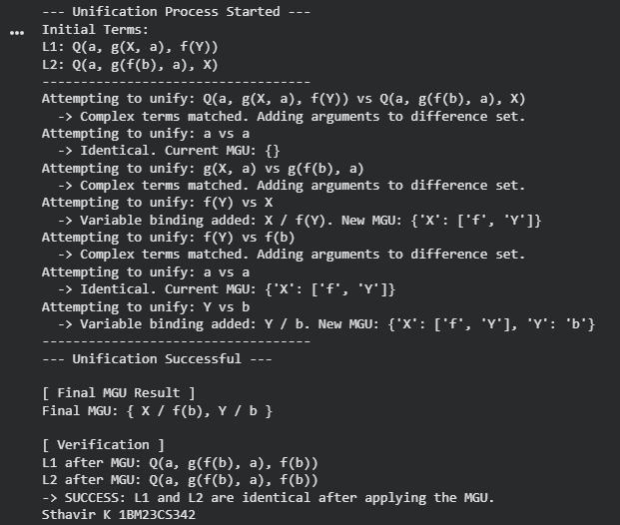

**Program 8**

Create a knowledge base consisting of first order logic statements and prove the given query using forward reasoning:

**Algorithm:**

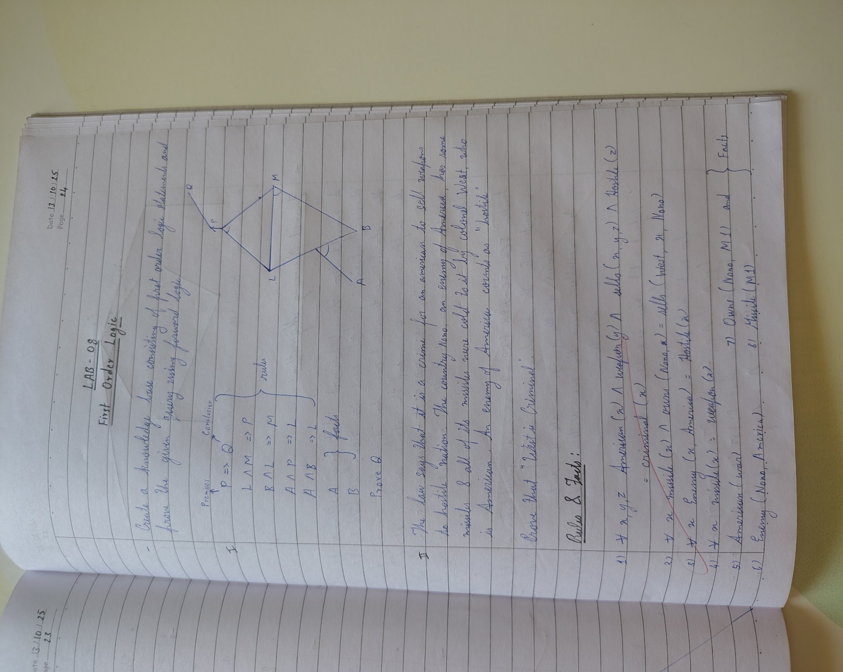

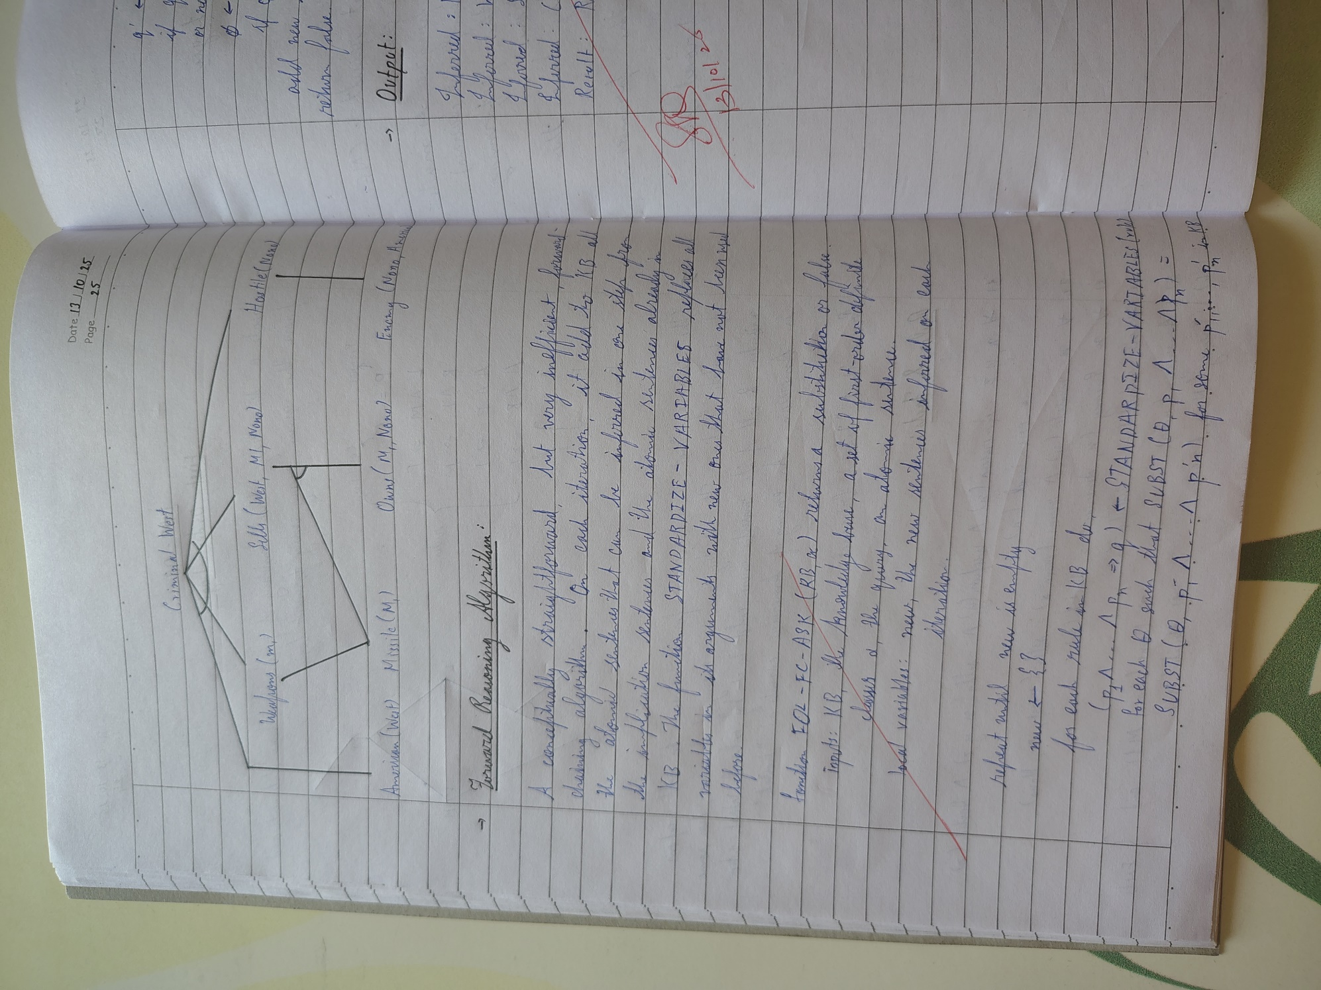

**Code :**

def FOL_FC_ASK(KB, alpha):

*# Initialize the new sentences to be inferred in this iteration*

new = set()

while new: *# Repeat until new is empty*

new = set() *# Clear new sentences on each iteration*

*# For each rule in KB*

for rule in KB:

*# Standardize the rule variables to avoid conflicts*

standardized_rule = standardize_variables(rule)

p1_to_pn, q = standardized_rule *# Premises (p1, ..., pn) and conclusion (q)*

*# For each substitution θ such that Subst(θ, p1, ..., pn) matches the premises*

for theta in get_matching_substitutions(p1_to_pn, KB):

q_prime = apply_substitution(theta, q)

*# If q_prime does not unify with some sentence already in KB or new*

if not any(unify(q_prime, sentence) != 'FAILURE' for sentence in KB.union(new)):

new.add(q_prime) *# Add q_prime to new*

*# Unify q_prime with the query (alpha)*

phi = unify(q_prime, alpha)

if phi != 'FAILURE':

return phi *# Return the substitution if it unifies*

*# Add newly inferred sentences to the knowledge base*

KB.update(new)

return False *# Return false if no substitution is found*

def standardize_variables(rule):

"""

Standardize variables in the rule to avoid variable conflicts.

Rule is assumed to be a tuple (premises, conclusion).

"""

premises, conclusion = rule

*# Apply standardization logic here (for simplicity, assume no conflict in this case)*

return (premises, conclusion)

def get_matching_substitutions(premises, KB):

"""

Get matching substitutions for the premises in the KB.

This is a placeholder to represent how substitutions would be found.

"""

*# Implement substitution matching here*

return [] *# This should return a list of valid substitutions*

def apply_substitution(theta, expression):

"""

Apply a substitution θ to an expression.

This function will replace variables in expression with their corresponding terms from θ.

"""

if isinstance(expression, str) and expression.startswith('?'):

return theta.get(expression, expression) *# Apply substitution to variable*

elif isinstance(expression, tuple):

return tuple(apply_substitution(theta, arg) for arg in expression)

return expression

def unify(psi1, psi2, subst=None):

"""Unification algorithm (simplified)"""

if subst is None:

subst = {}

def apply_subst(s_map, expr):

if isinstance(expr, str) and expr.startswith('?'):

return s_map.get(expr, expr)

elif isinstance(expr, tuple):

return tuple(apply_subst(s_map, arg) for arg in expr)

return expr

def is_variable(expr):

return isinstance(expr, str) and expr.startswith('?')

_psi1 = apply_subst(subst, psi1)

_psi2 = apply_subst(subst, psi2)

if is_variable(_psi1) or is_variable(_psi2) or not isinstance(_psi1, tuple) or not isinstance(_psi2, tuple):

if _psi1 == _psi2:

return subst

elif is_variable(_psi1):

if _psi1 in str(_psi2):

return 'FAILURE'

return {**subst, _psi1: _psi2}

elif is_variable(_psi2):

if _psi2 in str(_psi1):

return 'FAILURE'

return {**subst, _psi2: _psi1}

else:

return 'FAILURE'

if _psi1[0] != _psi2[0] or len(_psi1) != len(_psi2):

return 'FAILURE'

for arg1, arg2 in zip(_psi1[1:], _psi2[1:]):

s = unify(arg1, arg2, subst)

if s == 'FAILURE':

return 'FAILURE'

subst = s

return subst

*# Knowledge Base (KB)*

KB = set()

*# Adding facts to KB:*

KB.add(('american', 'Robert')) *# Robert is an American*

KB.add(('hostile_nation', 'Country_A')) *# Country A is a hostile nation*

KB.add(('sell_weapons', 'Robert', 'Country_A')) *# Robert sold weapons to Country A*

*# Adding the rule (the law):*

KB.add((('american(x)', 'hostile_nation(y)', 'sell_weapons(x, y)'),

'criminal(x)'))

*# Goal: Prove that Robert is a criminal*

goal = 'criminal(Robert)'

*# Calling FOL_FC_ASK to prove the goal*

result = FOL_FC_ASK(KB, goal)

if result != 'FAILURE':

print("Robert is a criminal!")

else:

print("Robert is not a criminal.")

**Output:**



**Program 9**

Create a knowledge base consisting of first order logic statements and prove the given query using Resolution

**Algorithm:**

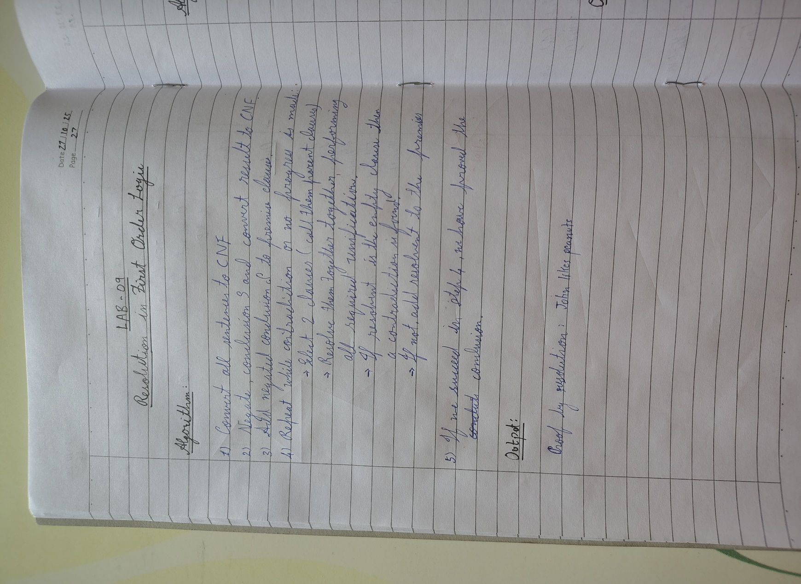

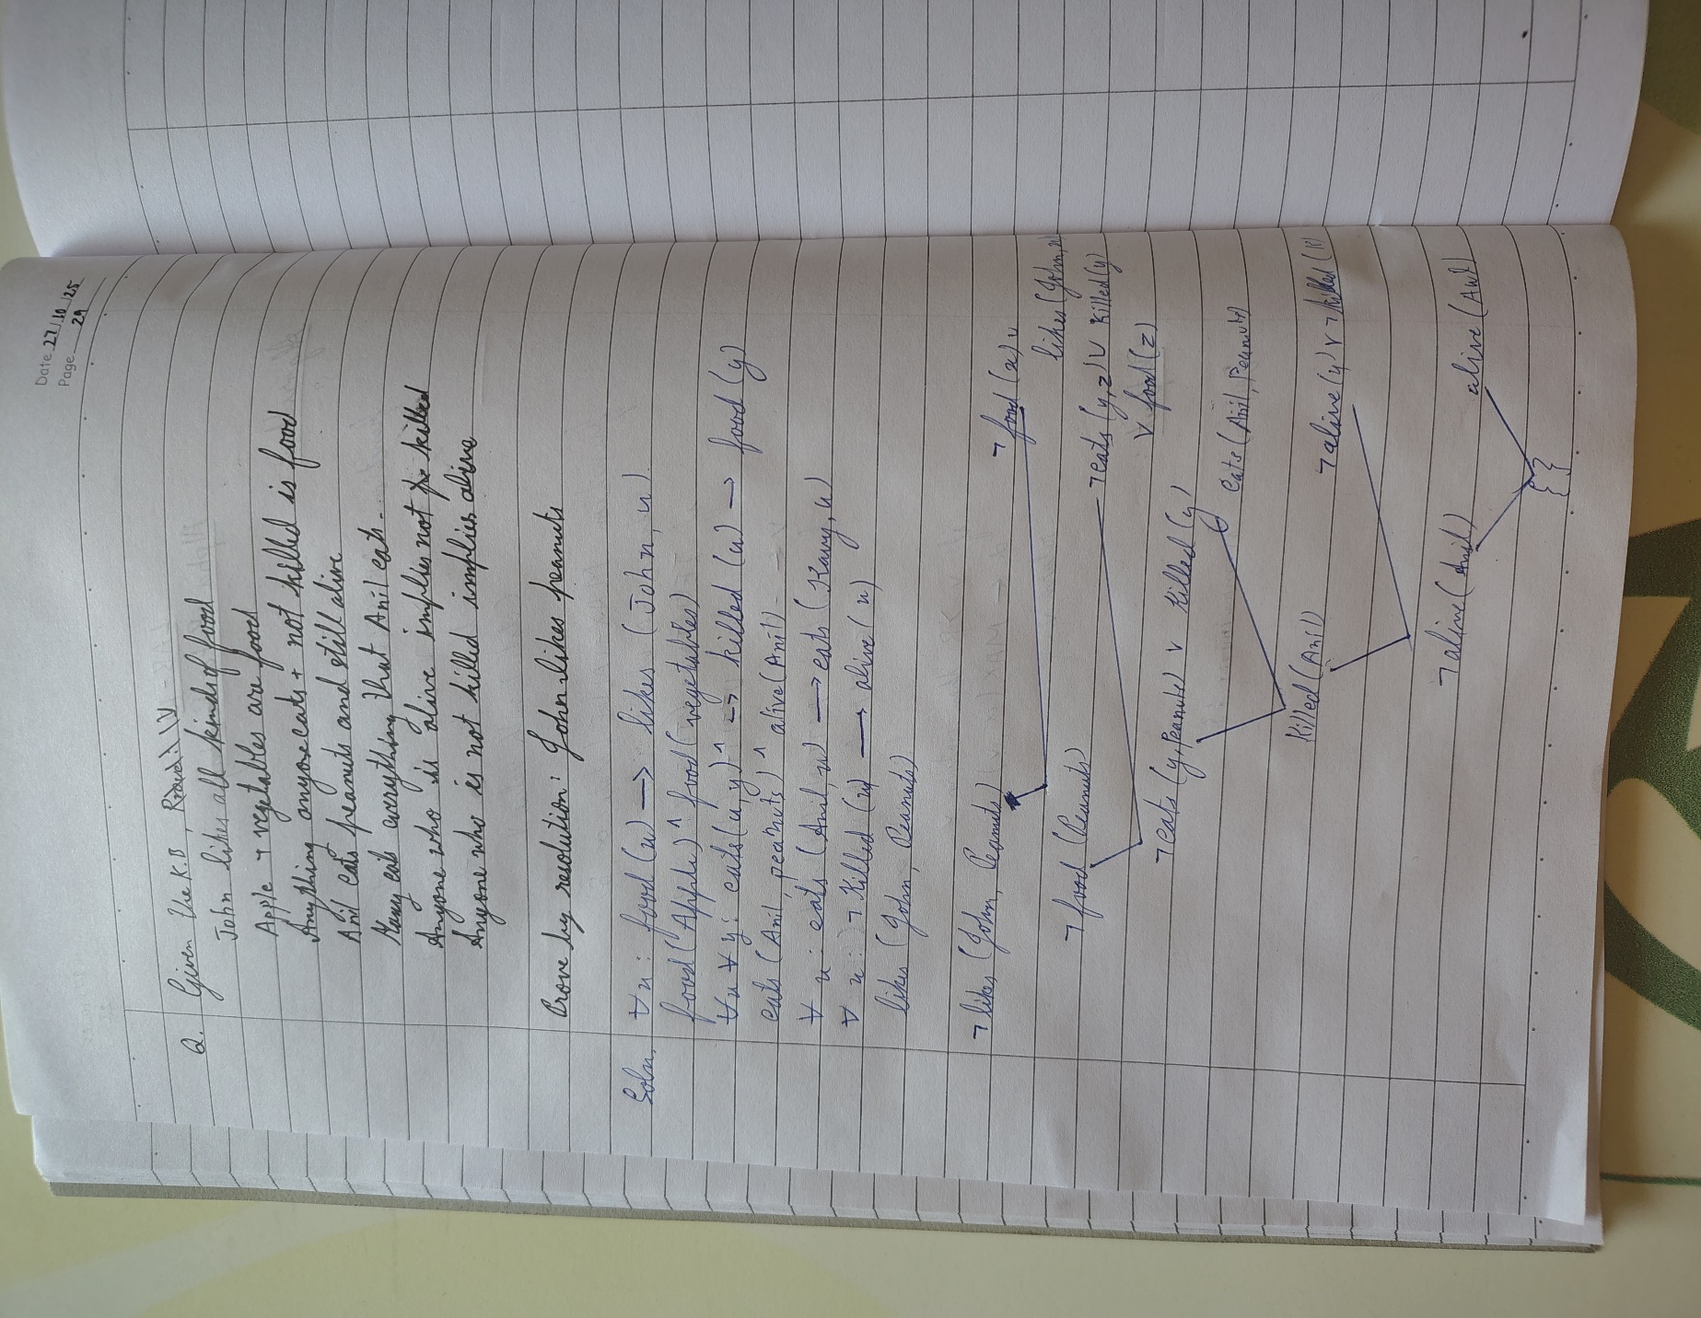

**Code:**

from itertools import combinations

def unify(x, y, theta=None):

if theta is None:

theta = {}

if x == y:

return theta

elif isinstance(x, str) and x.islower():

return unify_var(x, y, theta)

elif isinstance(y, str) and y.islower():

return unify_var(y, x, theta)

elif isinstance(x, tuple) and isinstance(y, tuple) and len(x) == len(y):

return unify(x[1:], y[1:], unify(x[0], y[0], theta))

else:

return None

def unify_var(var, x, theta):

if var in theta:

return unify(theta[var], x, theta)

elif x in theta:

return unify(var, theta[x], theta)

else:

theta[var] = x

return theta

def negate(predicate):

if isinstance(predicate, tuple) and predicate[0] == 'not':

return predicate[1]

else:

return ('not', predicate)

def substitute_predicate(predicate, theta):

if isinstance(predicate, str):

return theta.get(predicate, predicate)

elif isinstance(predicate, tuple):

return (predicate[0],) + tuple(theta.get(arg, arg) for arg in predicate[1:])

return predicate

def substitute(clause, theta):

return {substitute_predicate(p, theta) for p in clause}

def resolve(clause1, clause2):

resolvents = []

for p1 in clause1:

for p2 in clause2:

theta = unify(p1, negate(p2))

if theta is not None:

new_clause = (substitute(clause1, theta) | substitute(clause2, theta)) - {p1, p2}

resolvents.append(frozenset(new_clause))

return resolvents

def resolution(kb, query):

negated_query = frozenset({negate(query)})

clauses = kb | {negated_query}

new = set()

while True:

pairs = list(combinations(clauses, 2))

for (ci, cj) in pairs:

resolvents = resolve(ci, cj)

if frozenset() in resolvents:

return True

new |= set(resolvents)

if new.issubset(clauses):

return False

clauses |= new

*# Knowledge Base*

kb = {

frozenset({('not', ('Food', 'x')), ('Likes', 'John', 'x')}), *# a*

frozenset({('Food', 'Apple')}), *# b*

frozenset({('Food', 'Vegetables')}), *# b*

frozenset({('not', ('Eats', 'x', 'y')), ('Killed', 'x'), ('Food', 'y')}), *# c*

frozenset({('Eats', 'Anil', 'Peanuts')}), *# d*

frozenset({('Alive', 'Anil')}), *# d*

frozenset({('not', ('Eats', 'Anil', 'x')), ('Eats', 'Harry', 'x')}), *# e*

frozenset({('not', ('Alive', 'x')), ('not', ('Killed', 'x'))}), *# f*

frozenset({('Killed', 'x'), ('Alive', 'x')}), *# g*

}

query = ('Likes', 'John', 'Peanuts')

*# Run resolution*

result = resolution(kb, query)

if result:

print("Proved by resolution: John likes peanuts.")

else:

print("Cannot prove that John likes peanuts.")

**Output:**

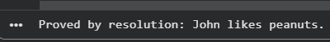

**Program 10**

Implement Alpha-Beta Pruning

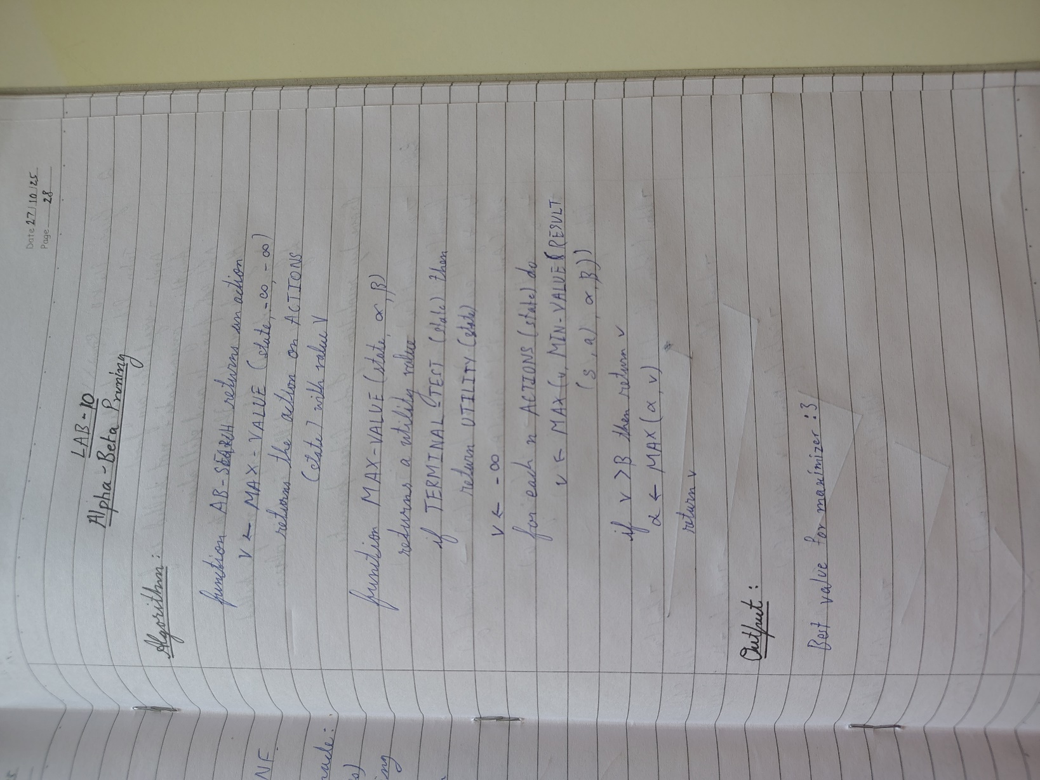

**Code:**

import math

def alpha_beta_search(state):

return max_value(state, -math.inf, math.inf)

def max_value(state, alpha, beta):

if terminal_test(state):

return utility(state)

v = -math.inf

for a in actions(state):

v = max(v, min_value(result(state, a), alpha, beta))

if v >= beta:

return v

alpha = max(alpha, v)

return v

def min_value(state, alpha, beta):

if terminal_test(state):

return utility(state)

v = math.inf

for a in actions(state):

v = min(v, max_value(result(state, a), alpha, beta))

if v <= alpha:

return v

beta = min(beta, v)

return v

values = [3, 5, 6, 9, 1, 2, 0, -1]

max_depth = 3

def terminal_test(state):

return state >= len(values) // 2**(max_depth - depth[state])

def utility(state):

return values[state]

def actions(state):

if depth[state] == max_depth:

return []

return [0, 1]

def result(state, action):

child = state * 2 + 1 + action

depth[child] = depth[state] + 1

return child

depth = {0: 0}

print("Best value for maximizer:", alpha_beta_search(0))

print("Sthavir / 1BM23CS342")

**Output :**

